DEEP LEARNING, M.L. AND NEURAL NETWORKS

**What are Deep Learning and Neural Network?**

**Deep learning** is a subset of [machine learning](https://www.ibm.com/cloud/learn/machine-learning) concerned with algorithms inspired by the structure and function of the human brain. DL systems can handle massive amounts of structured and unstructured data. The fundamental notion of deep learning is artificial neural networks, which allow machines to make decisions.

**Deep learning**, also known as **hierarchical learning**, is a subset of machine learning in artificial intelligence that can mimic the computing capabilities of the human brain

The primary distinction between deep learning and machine learning is how data is delivered to the machine. DL networks function on numerous layers of artificial neural networks, whereas machine learning algorithms often require structured input.

* The network has an input layer that takes data inputs.
* The hidden layer searches for any hidden characteristics in the data.
* The output layer subsequently provides the expected output.

Here's an example: That uses enormous amounts of unlabeled retinal data. This data is used to train the network model, which determines whether or not a person has diabetic retinopathy.

**Machine Learning vs Neural Network: Key Differences**

1. Machine Learning uses advanced algorithms that parse data, learns from it, and use those learnings to discover meaningful patterns of interest. Whereas a Neural Network consists of an assortment of algorithms used in Machine Learning for data modelling using graphs of neurons.

2. While a Machine Learning model makes decisions according to what it has learned from the data, a Neural Network arranges algorithms in a fashion that it can make accurate decisions by itself. Thus, although Machine Learning models can learn from data, in the initial stages, they may require some human intervention.

Neural networks do not require human intervention as the nested layers within pass the data through hierarchies of various concepts, which eventually makes them capable of learning through their own errors.

3. As we mentioned earlier, Machine learning models can be categorized under two types – supervised and unsupervised learning models. However, Neural Networks can be classified into feed-forward, recurrent, convolutional, and modular Neural Networks.

4. An ML model works in a simple fashion – it is fed with data and learns from it. With time, the ML model becomes more mature and trained as it continually learns from the data. On the contrary, the structure of a Neural Network is quite complicated. In it, the data passes through several layers of interconnected nodes, wherein each node classifies the characteristics and information of the previous layer before passing the results on to other nodes in subsequent layers.

5. Since Machine Learning models are adaptive, they are continually evolving by learning through new sample data and experiences. Thus, the models can identify the patterns in the data. Here, data is the only input layer. However, even in a simple Neural Network model, there are multiple layers.

**What is a Neural Network?**

The structure of the human brain inspires a Neural Network. A Neural Network is a web of interconnected entities known as nodes wherein each node is responsible for a simple computation. In this way, a Neural Network functions similarly to the neurons in the human brain. In other words, neural networks represent a collection of algorithms developed to identify patterns. They classify or group raw input to comprehend sensory data through machine perception. The real-world data, like texts, images, sounds, etc., should be transformed into vectors to allow neural networks to identify the patterns.

Neural networks can’t learn the fundamental rules if your dataset is small.  Its internal structure is difficult to comprehend.

**How do Deep Learning and Neural network work?**

* Neural networks are algorithms that can interpret sensory data via machine perception and label or group the raw data. They are designed to recognize numerical patterns contained in vectors that need to transform all real-world data (images, sounds, text, time series, etc.)
* In its simplest form, an Artificial Neural Network (ANN) has only three layers – the input layer, the output layer, and a hidden layer.
* The word “deep” in Deep Learning refers to the number of hidden layers i.e. depth of the neural network. Essentially, **every neural network with more than three layers, that is, including the Input Layer and Output Layer can be considered a Deep Learning Model. The number of hidden layers is commonly referred to as "deep."** Traditional **neural networks have just 2-3** hidden layers, but **deep networks may have up to 150.**
* Contrary to task-based algorithms, Deep Learning systems learn from data representations – they can learn from unstructured or unlabeled data.
* Because most **Deep Learning** approaches employ neural network architectures, DL models are frequently called deep neural networks.
* DL models are trained to learn features **directly from the data**, eliminating the requirement for human feature extraction.
* A deep learning network has many distinct layers, making it more sophisticated than a neural network.
* A DL system does tasks with excellent efficiency and performance, whereas it performs jobs with poor efficiency compared to a deep learning system.
* A DL unit's main components are an ample power supply, a GPU, and a large RAM. In contrast, its main components are neurons, learning rate, connections, propagation functions, and weight.
* Due to their complexity, DL networks need significant time to train, whereas neural networks require relatively little time to train.

*(Note: labeled data is used by Supervised Learning Techniques while, unlabeled data is used by Unsupervised Learning Technique)*

**Difference between Deep Learning and Machine Learning**

* Deep learning is a subset of machine learning. A [machine learning workflow](https://cloud.google.com/ai-platform/docs/ml-solutions-overview) begins with manually extracting important characteristics from images. After that, the characteristics are utilized to build a model that categorizes the objects in the image. Relevant characteristics from images are automatically retrieved using a DL approach. Furthermore, DL does "end-to-end learning," A network is given raw data and a job to fulfill, such as classification, and it automatically learns how to do so.
* DL techniques scale as data increases, whereas shallow learning converges. Shallow learning refers to machine learning algorithms that reach a peak in performance when additional instances and training data are added to the network.
* DL networks have a significant benefit in that they frequently improve as the quantity of your data grows.

CONCLUSION:

Neural Networks are essentially a part of Deep Learning, which in turn is a subset of Machine Learning. So, Neural Networks are nothing but a highly advanced application of Machine Learning that is now finding applications in many fields of interest.

**Architecture**

**Neural Network architectures in detail:**

* **Feedforward Neural Networks** – This is the most common type of neural network architecture, with the first layer being the input layer and the last layer being the output layer. All middle layers are hidden layers.
* **Recurrent Neural Network**– This network architecture is a series of ANNs in which connections between nodes form a directed graph along a temporal sequence. Therefore, this type of network exhibits dynamic behavior over time.
* **Symmetrically Connected Neural Networks**– These are similar to recurrent neural networks, with the only difference being that the connections between units are symmetric in symmetrically connected neural networks (i.e. same weight n both directions).

**Deep Learning model architectures in detail:**

* **Unsupervised Pre-Trained Network** – As the name implies, this architecture is pre-trained based on past experiences and does not require formal training. These include A*utoencoders* and *Deep Belief networks*
* **Convolutional Neural Network**(as name suggests, THEY USE NEURAL NETWORKS)– This is a deep learning algorithm that can take an input image, assign meaning to various objects in the image (learnable weights and biases), and distinguish between these objects.
* **Recursive Neural Network** (as name suggests, THEY USE NEURAL NETWORKS )– This is created by recursively applying the same set of weights to a structured input and passing a topological structure to generate a structured prediction over a scalar prediction on a variable-size input structure.

**NOTE:** CNN and RNN are subsets of Neural Network . But, they were later in time, classified as Deep Learning (‘Deep learning’ term was coined much later on in time, after Neural network was coined. Then a few N.N. algorithms were modified and later termed as D.L. algorithmms) Essentially, entire D.L. is a subset of Neural Network.

**NOTE**: IN ORDER TO STUDY DEEP LEARNING (with more than 1 hidden layers ), you must first study NEURAL NETWORKS (with 1 or 0 hidden layers).

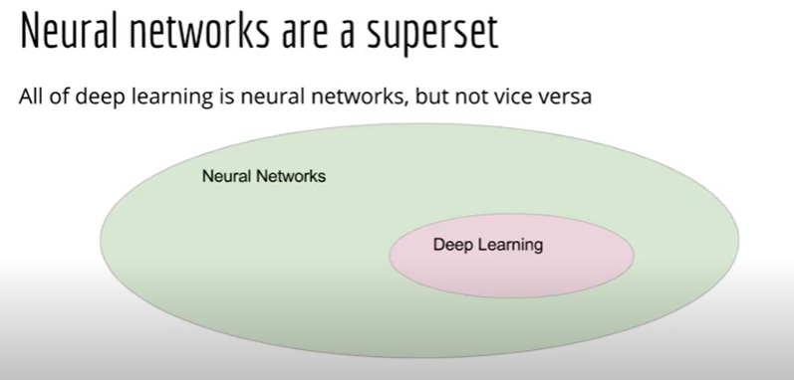

**Why is deep learning taking off?**

* Deep learning is taking off for 3 reasons:
  1. Data:
     + Using this image we can conclude:
       - [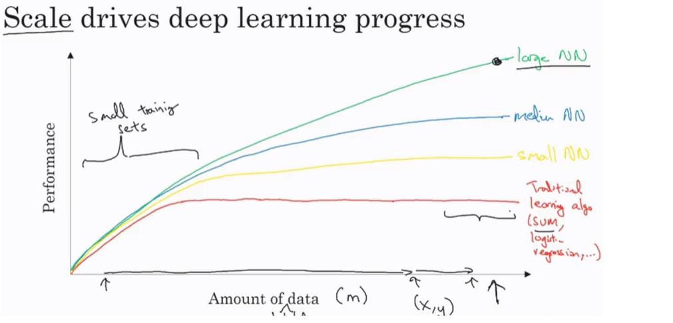](https://raw.githubusercontent.com/ashishpatel26/DeepLearning.ai-Summary/master/1-%20Neural%20Networks%20and%20Deep%20Learning/Images/11.png)
     + For small data, NN can perform as good as Linear regression or SVM (Support vector machine) or any other ML model.
     + For big data a small NN is better than any ML model. NOTE: For big data a big NN is better that a medium NN is better that small NN.
     + We now have a lot of data because the world is using the computer a little bit more
       - Mobiles
       - IOT (Internet of things)

This calls for use of DL more and more because DL’s accuracy keeps on increasing as the amount of training data goes on increasing.

* 1. Algorithm:
     + Creative algorithms has appeared that changed the way NN works.
       - For example using RELU function is so much better than using SIGMOID function in training a NN because it helps with the vanishing gradient problem.

**Note:**

Computations in Deep Learning model require certain powerful hardwares as well, like

* + - GPUs.
    - Powerful CPUs.
    - Distributed computing.
    - ASICs

**What is a Neural Network?**

Let’s begin with the crux of the matter and a very critical question. What is a neural network?

Consider an example where we have to predict the price of a house. The variables we are given are the size of the house in square feet (or square meters) and the price of the house. Now assume we have 6 houses. So first let’s pull up a plot to visualize what we’re looking at:

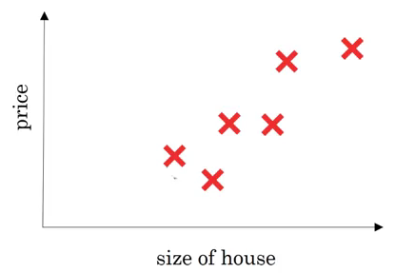 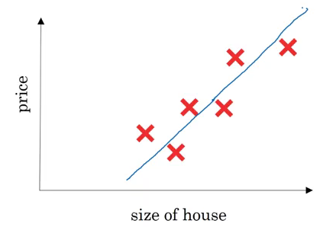

On the x-axis, we have the size of the house and on the y-axis we have it’s corresponding price. A linear regression model will try to draw a straight line to fit the data:

So, the input(x) here is the size of the house and output(y) is the price. Now let’s look at how we can solve this using a simple neural network: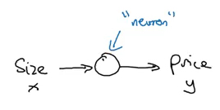

Here, a neuron will take an input, apply some activation function to it, and generate an output. One of the most commonly used activation function is ReLU (Rectified Linear Unit 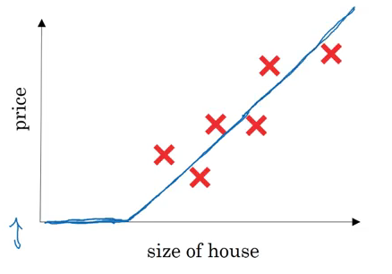

ReLU takes a real number as input and returns the maximum of 0 or that number. So, if we pass 10, the output will be 10, and if the input is -10, the output will be 0. We will discuss activation functions in detail later in this article.

For now let’s stick to our example. If we use the ReLU activation function to predict the price of a house based on its size, this is how the predictions may look:

So far, we have seen a neural network with a single neuron, i.e., we only had one feature (size of the house) to predict the house price. But in reality, we’ll have to consider multiple features like number of bedrooms, postal code, etc.? House price can also depend on the family size, neighbourhood location or school quality. How can we define a neural network in such cases?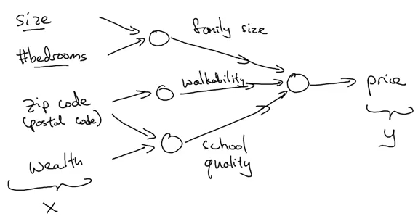

It gets a bit complicated here. Refer to the above image as you read – we pass 4 features as input to the neural network as x, it automatically identifies some hidden features from the input, and finally generates the output y. This is how a neural network with 4 inputs and an output with single hidden layer will look like: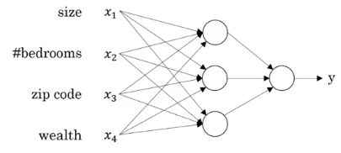

Now that we have an intuition of what neural networks are, let’s see how we can use them for supervised learning problems.

**Supervised Learning with Neural Networks**

Supervised learning refers to a task where we need to find a function that can map input to corresponding outputs (given a set of input-output pairs). We have a defined output for each given input and we train the model on these examples. Below is a pretty handy table that looks at the different applications of supervised learning and the different types of neural networks that can be used to solve those problems:

|  |  |  |  |
| --- | --- | --- | --- |
| **Input (X)** | **Output (y)** | **Application** | **Type of Neural Network** |
| Home Features | Price | Real Estate | Standard Neural Network |
| Ad, user info | Click prediction (0/1) | Online Advertising | Standard Neural Network |
| Image | Image Class | Photo Tagging | CNN |
| Audio | Text Transcript | Speech Recognition | RNN |
| English | Chinese | Machine Translation | RNN |
| Image, Radar info | Position of car | Autonomous Driving | Custom / Hybrid NN |

Below is a visual representation of the most common Neural Network types: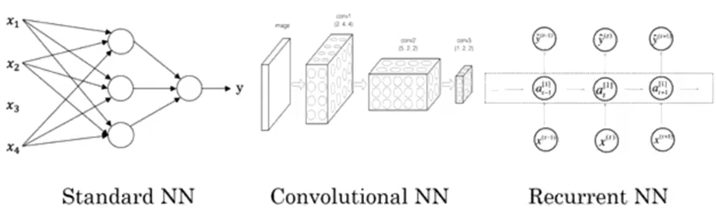

In our house price prediction example, the given data tells us the size and the number of bedrooms. This is **structured data, meaning that each feature, such as the size of the house, the number of bedrooms, etc. has a very well defined meaning.**

In contrast, **unstructured data refers to things like audio, raw audio, or images where you might want to recognize what’s in the image or text (like object detection).** Here, the features might be the pixel values in an image, or the individual words in a piece of text. It’s not really clear what each pixel of the image represents and therefore this falls under the unstructured data umbrella.

**NOTE: Do Not get confused, supervised learning can be used on both structured and unstructured data.**

* 1. **Coding a Layer : 1 neuron wit 3 inputs**

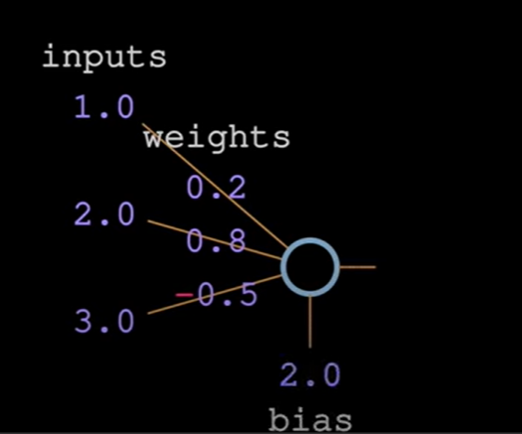

**We have a weight associated per input.**

**We have ONLY ONE bias per Neuron.**

Inputs can be coming from

* The first layer or the Input layer
* The other hidden layers or other neurons .

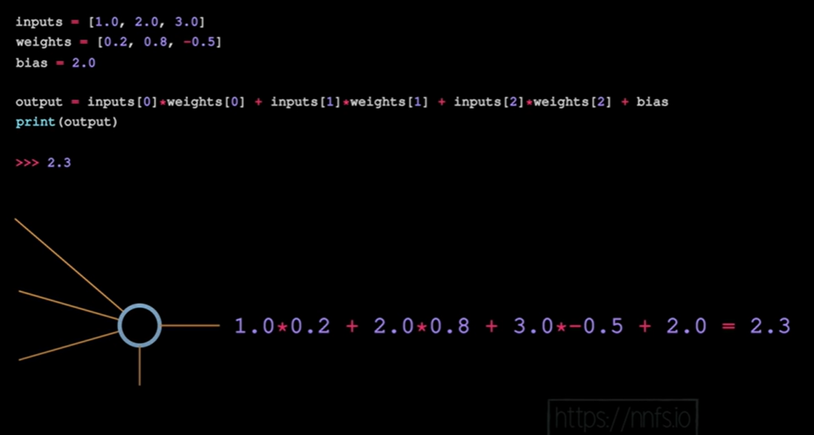

Thus, For a given X vector, the output will be:

**y = w(transpose)X + b**

* 1. **Coding a Layer : 3 neuron with 4 inputs**

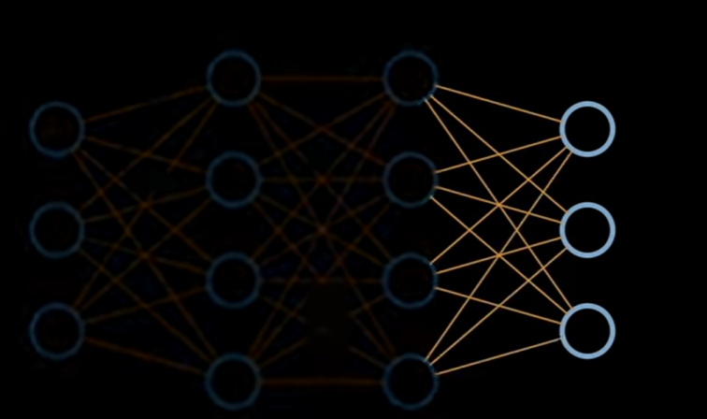

**Step 1 :**

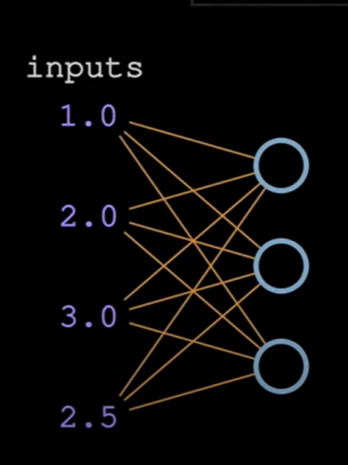

Each input neuron has 1 value as its output, which is further acting as a input to the 3 neurons that we want to code (shown as circle in above pic**). Thus for each neuron we have same set of input values i.e. 1,2,3 and 2.5**

Step 2:

Each neuron has a UNIOQUE set of weights fine tuned for each input value . Thus we have 3 sets of weights (one per neuron ). Also each neuron has ONLY ONE bias value.

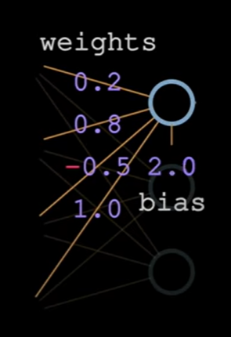 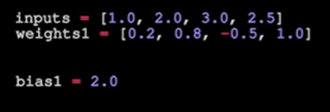

Thus for all the 3 neurons , we have :

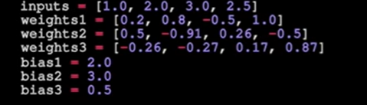

Finally, we take dot product + bias for EACH neuron separately and get the output:

4.8 for 1st neuron

1.21 for 2nd neuron

2.385 for 3rd neuron

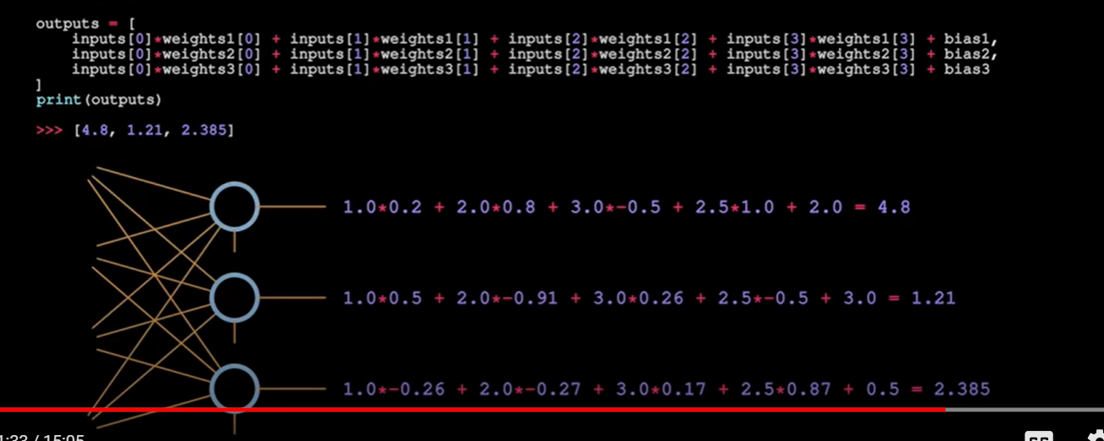

**NOTE: The crux of N.N. is not figuring out the output BUT, to tune the values of these “WEIGHTS” and “BIASES” parameters to get the best output with highest accuracy.** We cannot change the input values directly b/c they are either given to us or are generated by previous layer of neurons.

**BASICS OF VECTOR, ARRAY, TENSOR and MATHS :**

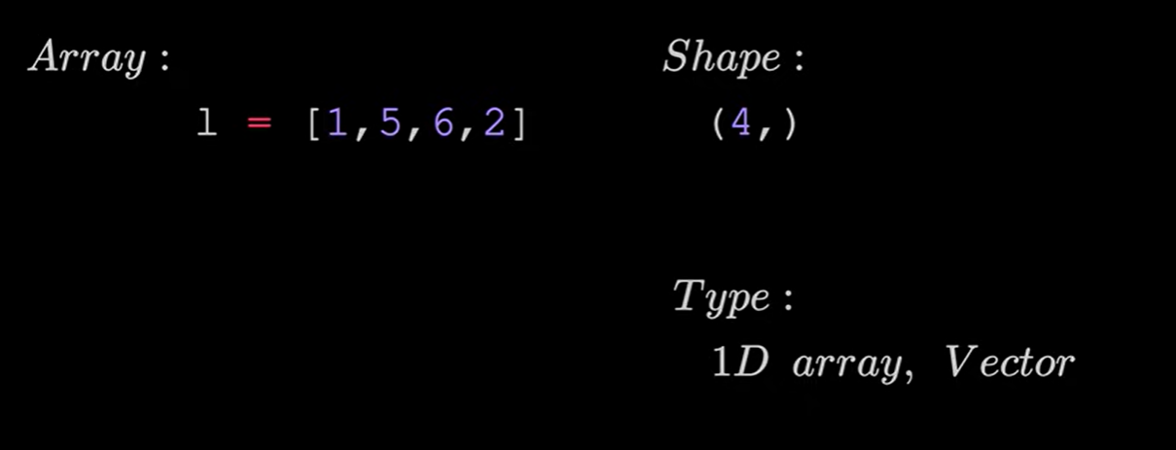

**NOTE: a list can be an ARRAY in numpy and it can be represented as a vector in Maths.(see above fig.)**

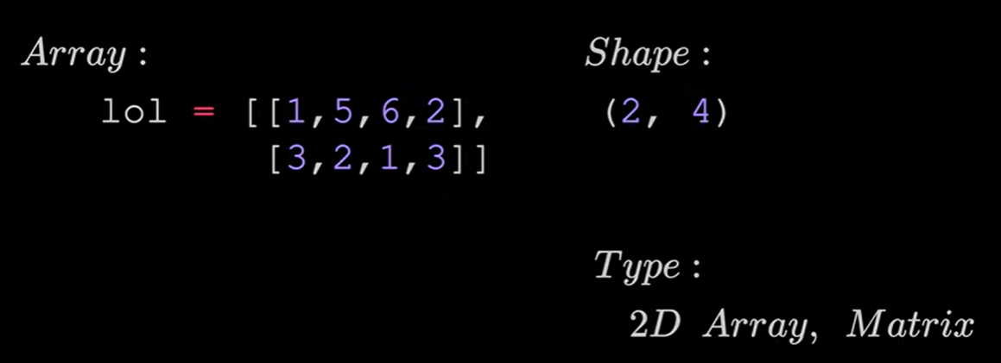

**NOTE: a “list of lists” can be an “nD ARRAY” in numpy and it can be represented as a Matrix in Maths. (see above fig.)**

**A matrix is simply a rectangular array . i.e.in terms of maths, a list of vectors is a Matrix.**

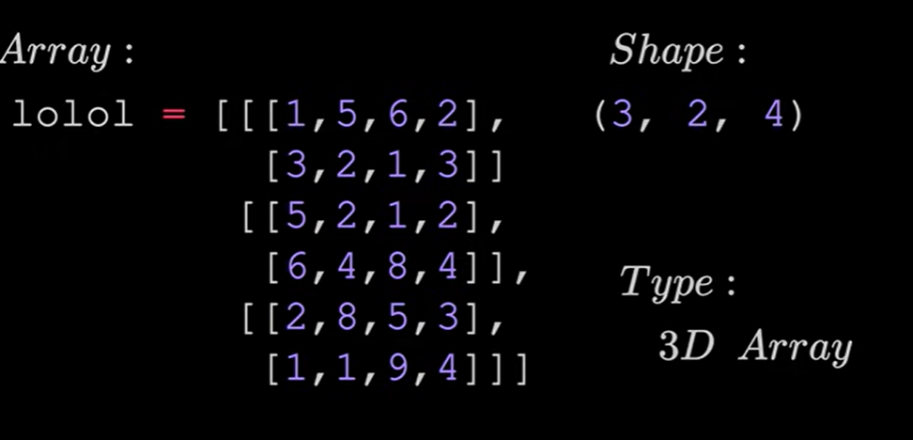

FIG: A list of list of list (lolol).

In above fig, shape is (3,2,4) b/c it has 3 rows (so,3), 2 columns(so,2) and inside each, we have 4 elements (so,4) . This a 3D array b/c it has 3 parameters which are needed to describe it.

**TENSOR:**

A Tensor is an Object that can be represented as an Array. (It is not an array)

**The DOT Product:**

Recall, the output of a dot product is a scalar.

In numpy, we can directly use “np.dot( pass_in_ur_vectors/arrays/matrices)”

Example: Dot product calculations for 1 neuron (per neuron only)

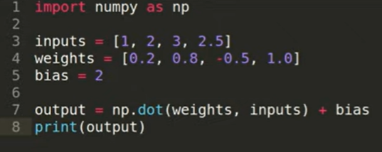

Output = 4.8

Example: Dot product calculations for 3 neurons forming a layer

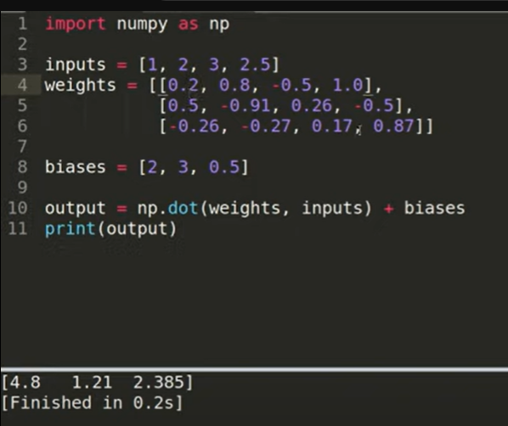

**Note(see above pic): We are Always passing in “Weights” before “Inputs” b/c then only the matrix Multiplication will work i.e. Weights(3,4) and inputs(4,) will work, while the other way round will fail.**

**The dot product works as follows:**

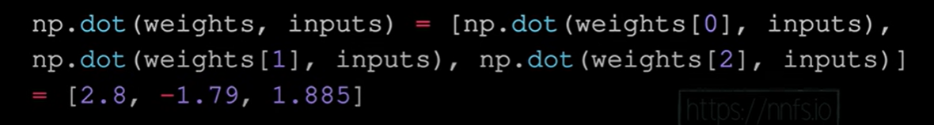

**TOOLS FOR ADJUSTING OUTPUT: WEIGHTS and BIASES**

The main equation for Output is clearly a linear Eqn:

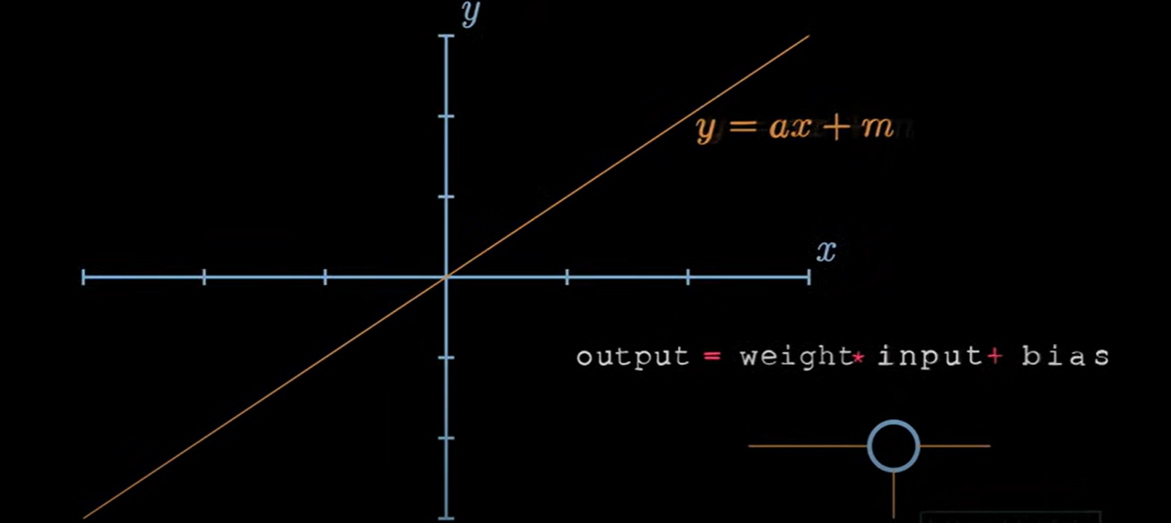

**Changing Weights only (see below)**

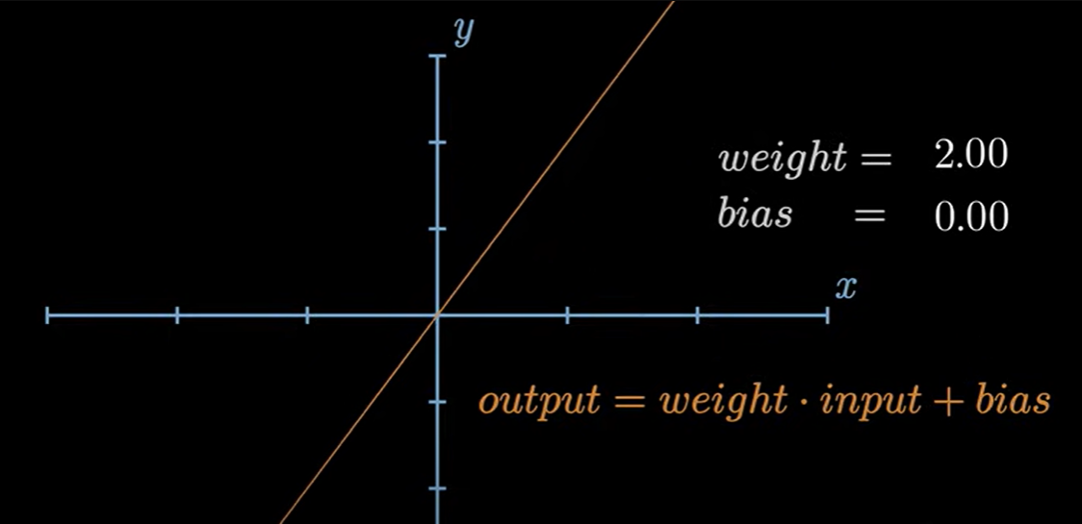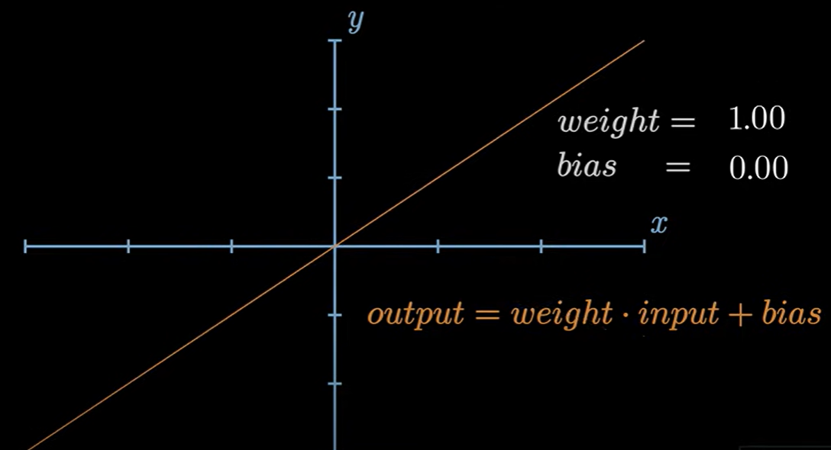

**Changing Weights and Biases both (see below)**

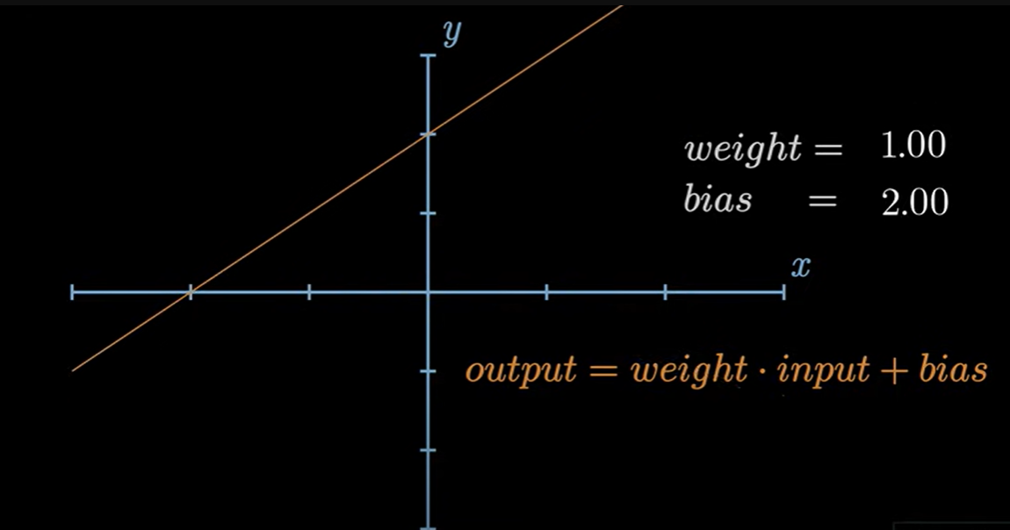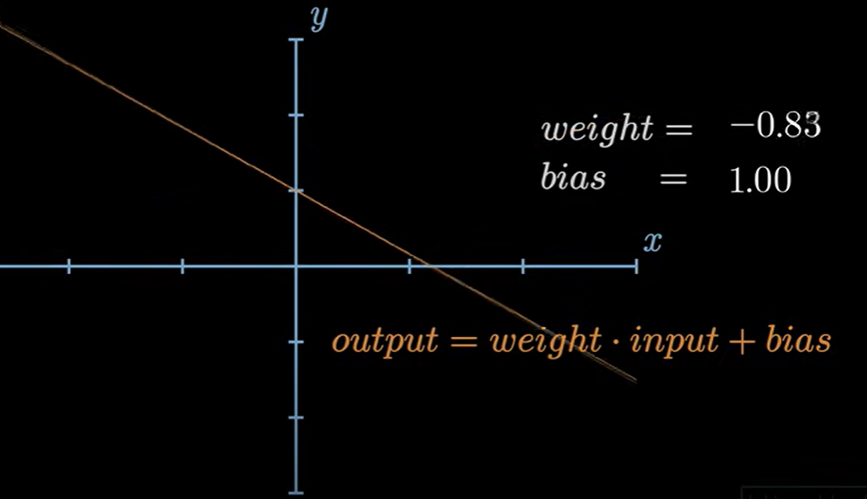



Video: RELU + adjusting of Weights and Biases

**BATCHES, LAYERS AND OBJECTS**

* **BATCHES**

**Introducing Batch Size**

Put simply, **the *batch size* is the number of samples that will be passed through to the network at one time.** Note that a batch is also commonly referred to as a mini-batch.

Note: For now just know that **an *epoch* is one single pass over the entire training set to the network. The batch size and an epoch are not the same thing.** Let's illustrate this with an example.

#### Difference : Batches In An Epoch

Let's say we have 1000 images of dogs that we want to train our network on in order to identify different breeds of dogs. Now, let's say we specify our batch size to be 10. This means that 10 images of dogs will be passed as a group, or as a batch, at one time to the network.

Given that a single epoch is one single pass of all the data through the network, it will take 100 batches to make up full epoch. We have 1000 images divided by a batch size of 10, which equals 100 total batches.

**batches in epoch = training set size / batch_size**

Q: Ok, we have the idea of batch size down now, but what's the point? Why not just pass each data element one-by-one to our model rather than grouping the data in batches?

**Need for taking** *Transpose* **of weights** : This is done to solve/ avoid Error due to shape mismatch while taking dot product (essentially Matrix multiplication of each column of weights(transpose) with each row of input/batches matrix.)

Recall this example from above: But with modification that, it has 3 inputs with a Batch size=4.

 

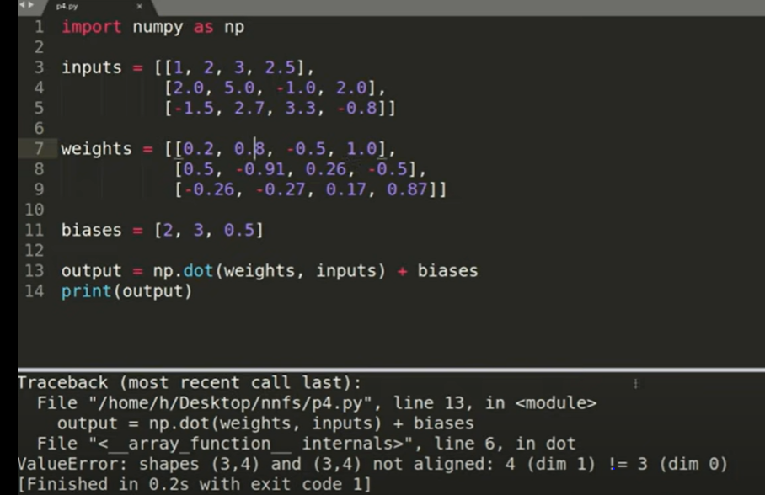

Fig above: Without Transpose : Error due to shape mismatch – Weights(3,4) and Inputs(3,4). And wkt from matrix basics, these cannot be multiplied.

**Hence, we need to take transpose of weight and then multiply to get dot product of each of the columns with rows individually.**

**To do that, use- *“ np.array(weights).T ”***

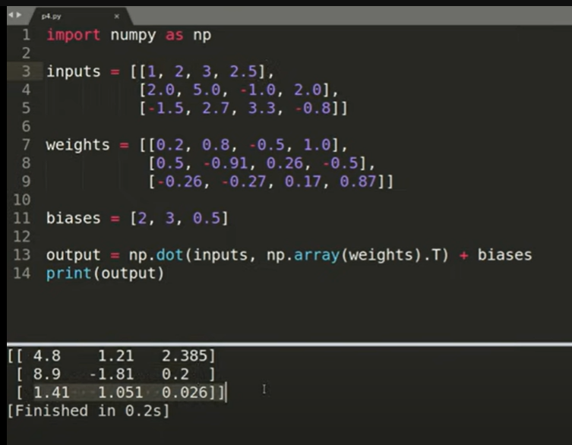

Thus, as seen above we are now able to get dot product (with the help of matrix multiplication) of each column of weights(transpose) with each row of input/batches matrix.

**NOTE:**

1. The above shows that : dot product b/w columns and rows individually of the 2 matrixes **is same as (or) can be accomplished by** Matrix multiplication b/w the two whole matrixes.
2. When we use np.dot(), the inside i/p are automatically converted to np arrays, BUT, since we want to use the Transpose feature only available in numpy, THUS, we use here with Weights to get its transpose before the dot product is taken.
3. The first output row (4.8 , 1.21, 2.385) represents output of the 3 neurons respectively Corresponding to the first Batch of input i.e corresponding to (1,2,3,2.5) .



Slly, the 2nd and 3rd row represents output for 2nd and 3rd batch of input.

Maths is simply the matrix multiplication followed by addition shown below:

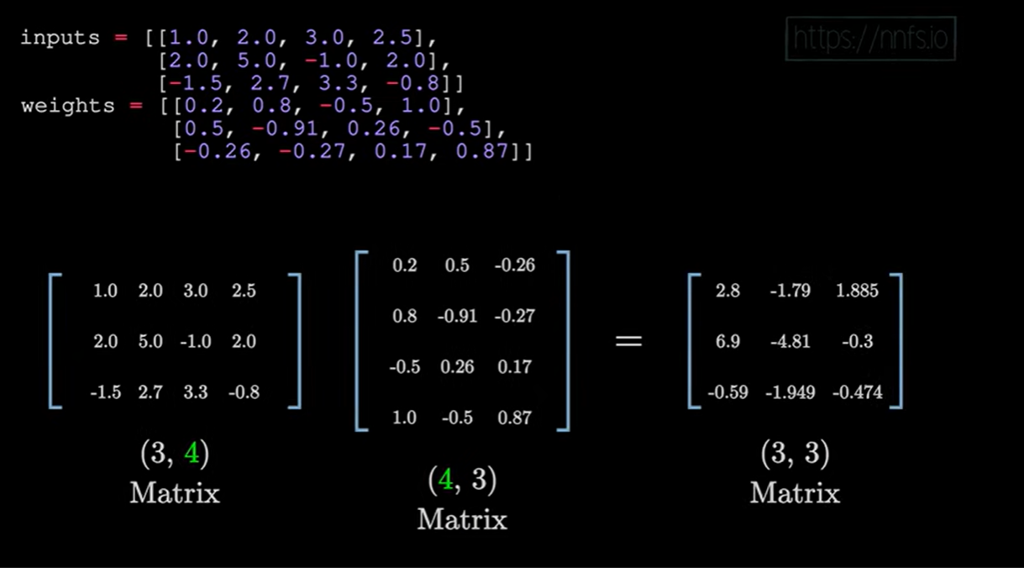

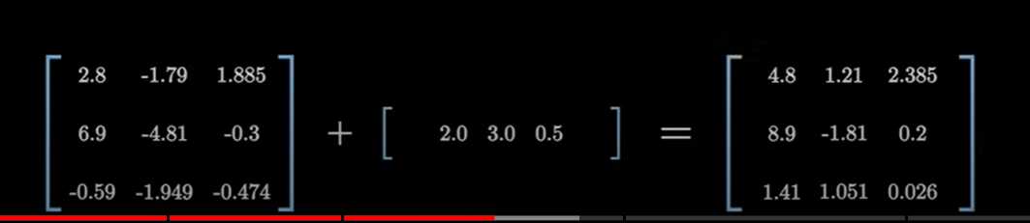

ADDING ANOTHER LAYER:

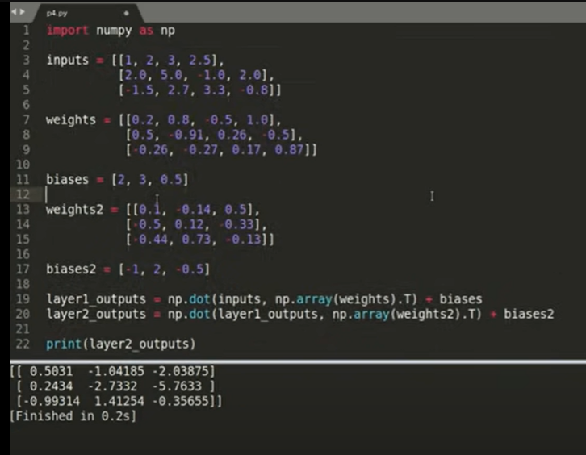

CODING POINTS TO KEEP IN MIND:

1. We normalize all the values (inputs,weights and biases) so that they are brought within a certain limit. This is done necessarily, otherwise, we have explosion of values even though we started with less values like 2 or 3. This happens b/c we are dealing with Multiple Layers with each layer undergoing Matrix Multiplication and wkt Matrix multiplication can do that.
2. **Thumb rule for Normalizing:**

**Inputs: -1 to 1**

**Weights : -0.1 to 0.1**

**Biases: initialize with 0 ,**

but it is later changed.

(BUT, initializing biases wit 0 may **sometimes** lead to an issue of getting an output as 0 always, called Dead Network)

**HIDDEN LAYER ACTIVATION:**

**What is an activation Function?**

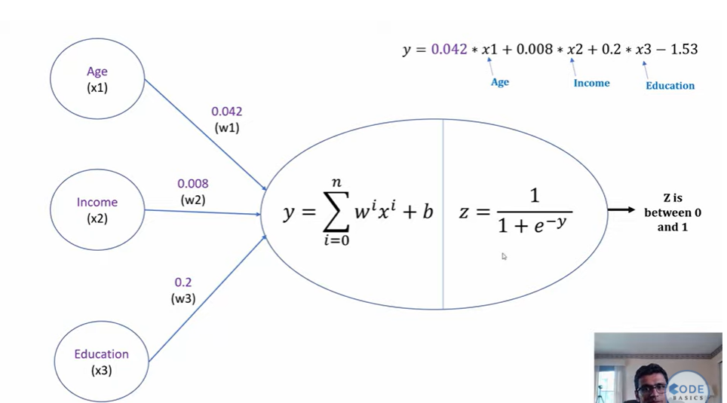

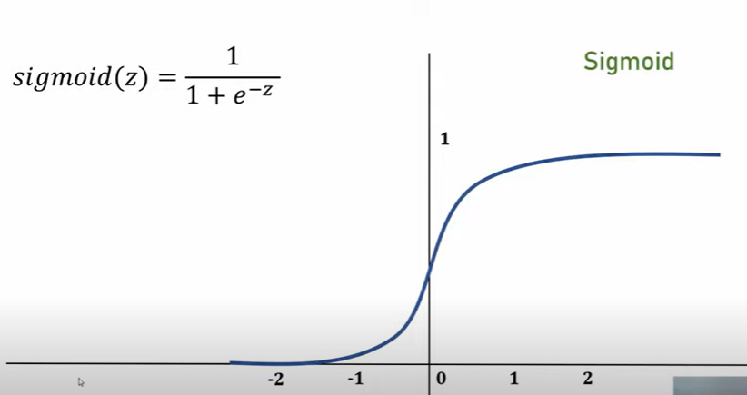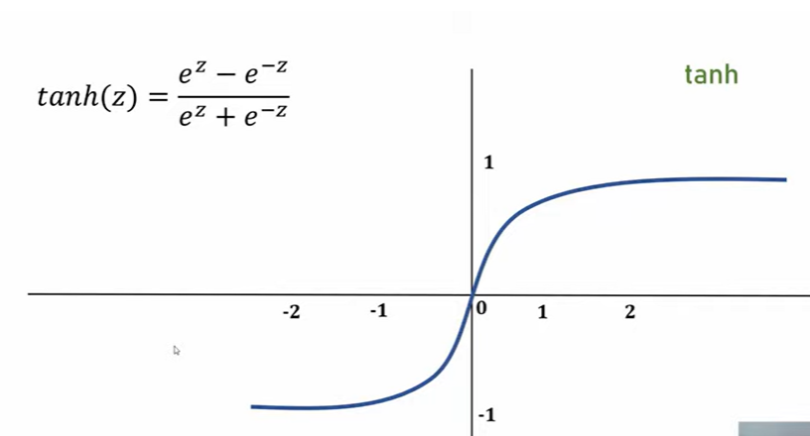

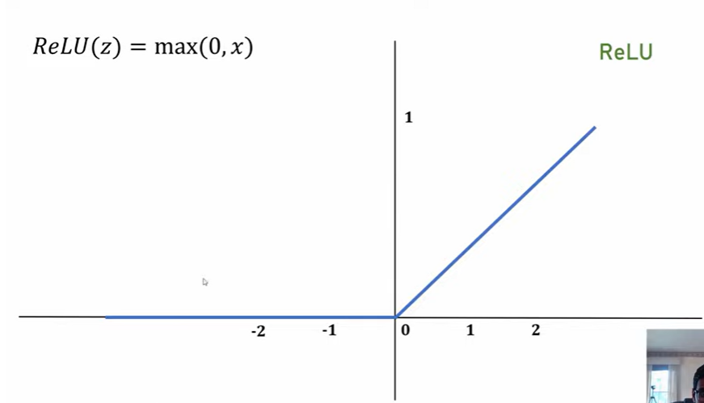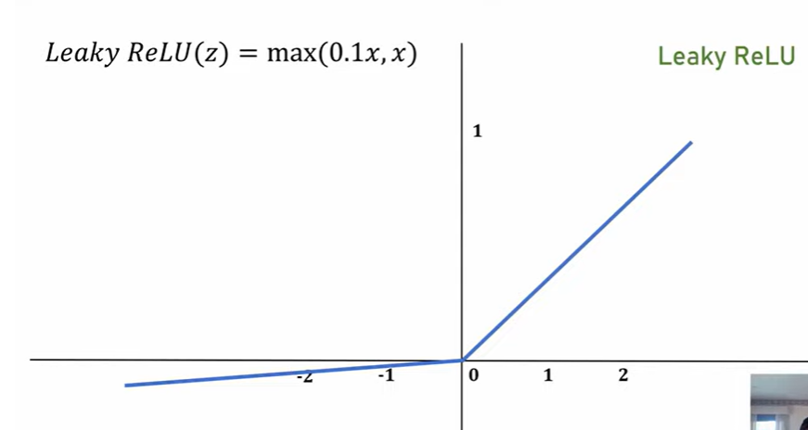

**Which to choose?**

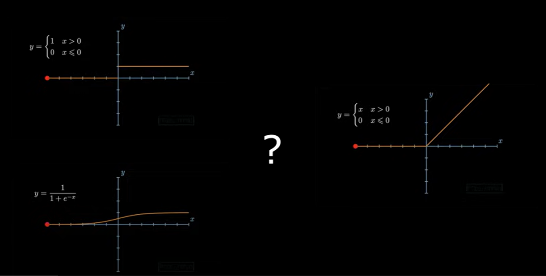

Fig: Various Activation Functions

* Sigmoid activation function range is [0,1] A = 1 / (1 + np.exp(-z)) # Where z is the input matrix
* Tanh activation function range is [-1,1] (Shifted version of sigmoid function)
* It turns out that the tanh activation usually works better than sigmoid activation function for hidden units because the mean of its output is closer to zero, and so it centers the data better for the next layer.
* Sigmoid or Tanh function **disadvantage is that if the input is too small or too high, the slope will be near zero which will cause us the gradient decent problem called as “VANISHING GRADIENT” problem.**

**Q: Why do we need so many Activation Functions? Why not just use a Linear Activation Fn?**

If we removed the activation function from our algorithm that can be called linear activation function and it will linear b/c it is same as out = input*weight +bias (a linear eqn indeed) .

**We cannot use this** B/c as seen below, Linear AF fails to capture the full essence of the input signal .

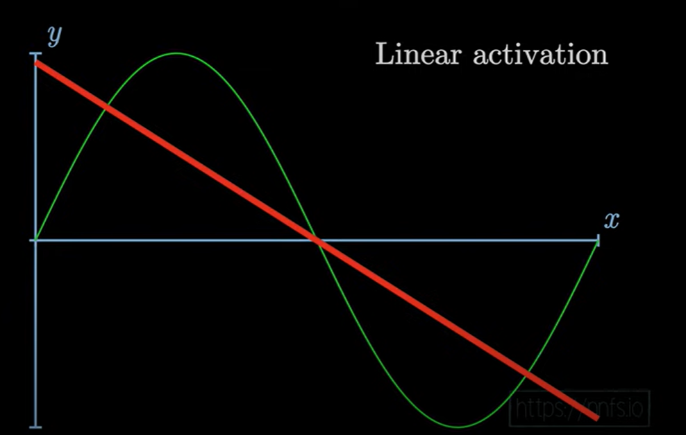 This is how a Linear Af fits to an input sine curved signal.

On the other Hand, a RELU fits much better (see below)

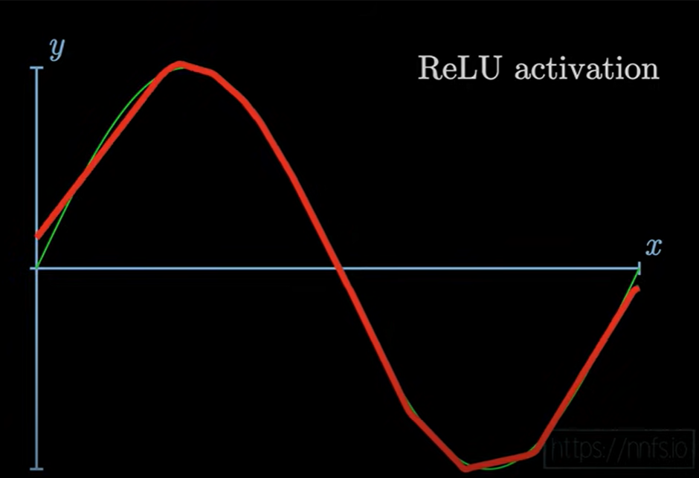

* One of the popular activation functions that solved the slow gradient decent is the RELU function. RELU = max(0,z) # so if z is negative the slope is 0 and if z is positive the slope remains linear.
* **Leaky RELU activation function different of RELU is that if the input is negative the slope will be so small**. It works as RELU but most people uses LRELU.

*Leaky_RELU = max(0.01z,z) #the 0.01 can be a parameter for your algorithm.*

**Basic RULE to choose Activation Function is:**

***If your classification is between 0 and 1, use the output activation as sigmoid and for the others use RELU.***

**RELU (Rectified Linear Unit) Activation Function**

**Why RELU ?**

* Solved the slow gradient decent, BUT NOTE that it still has a vanishing gradient problem, which is solve by LeakyRLEU
* It is a Linear Function, which makes computations really really fast (compared to sigmoid, tanh fns which are Non-Linear and take more computation time)

**How does RELU work?**

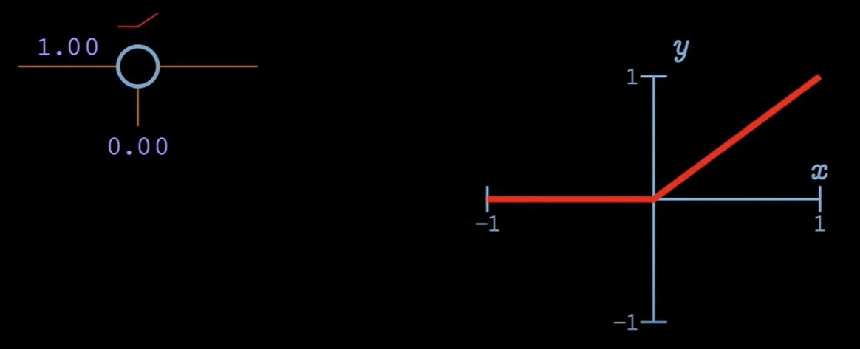 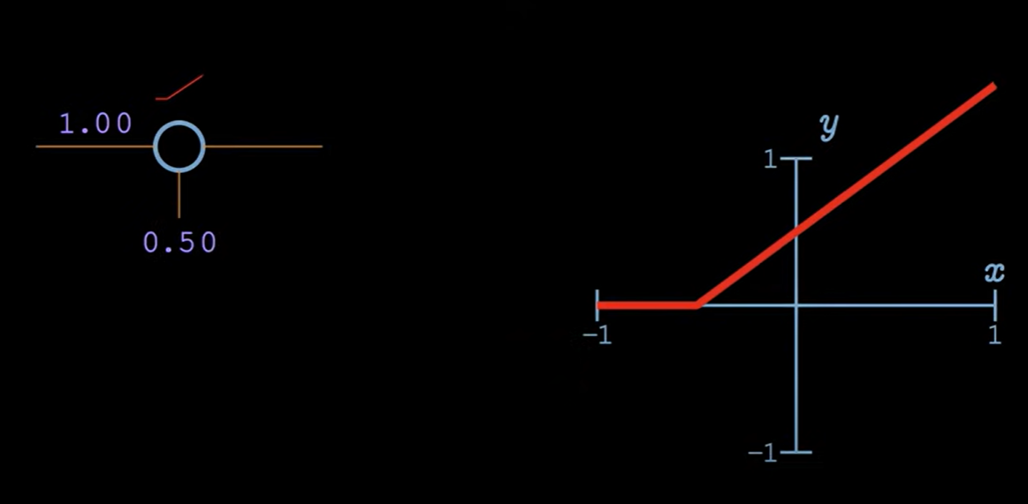

Fig: Increasing Weight only slope changes Fig: Increasing Bias value to offset Activation Pt.

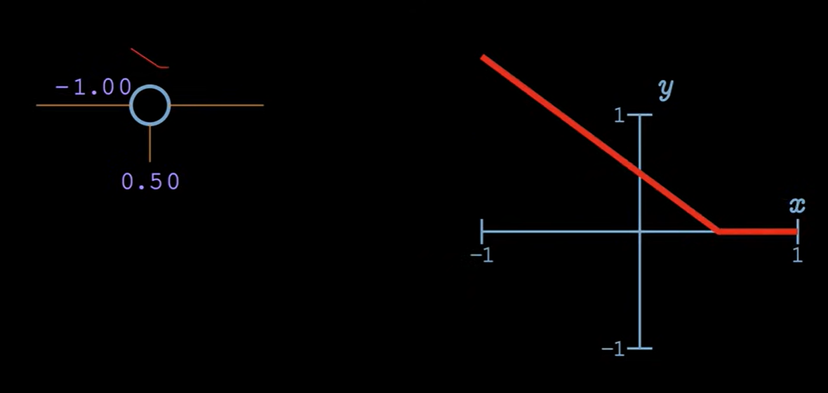

Fig: By Negating the Weight value (**-**1.00 here), we can change the nature of RELU fn and now we can set the **de-activation pt.** rather than setting the Activation pt. as done in previous figures.

By controlling the weights and biases of 2 Neurons (see below), we can set the upper and lower Limit in a RELU Activation Fn**. This would allow us to better capture complex signals as sine curve shown earlier.**

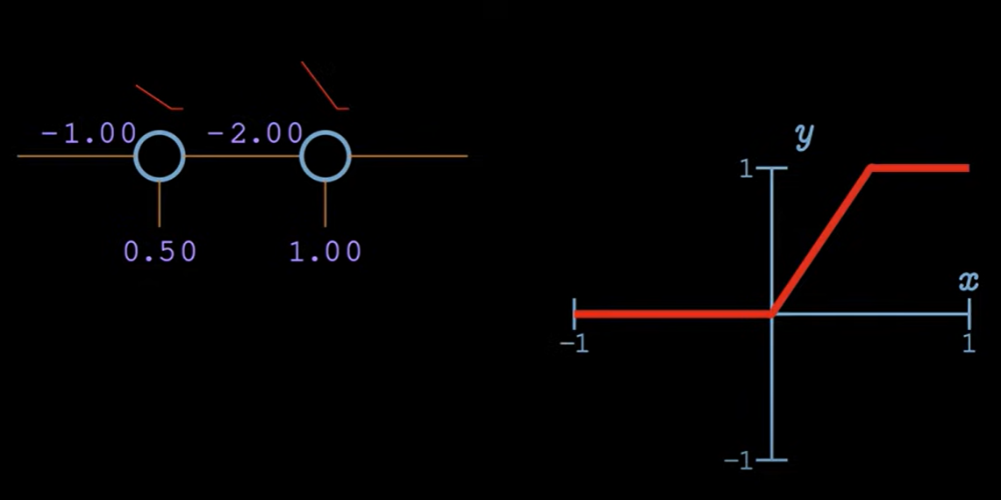

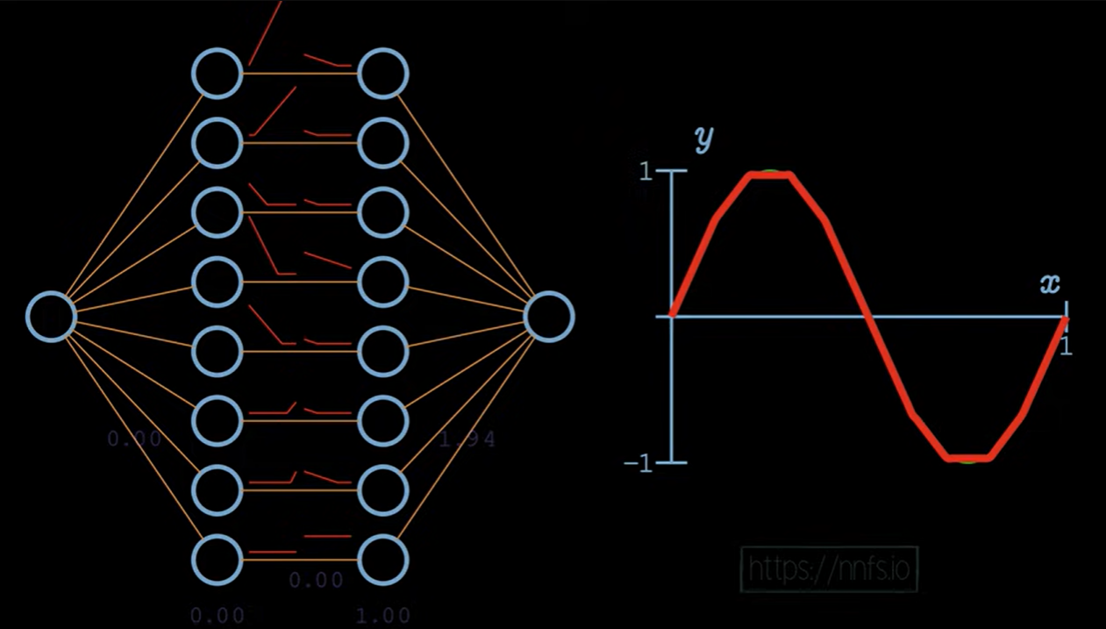

SEE VIDEO FOR MORE:



**SOFTMAX ACTIVATION FUNCTION:**

The softmax function is a function that turns a [vector](https://deepai.org/machine-learning-glossary-and-terms/vector) of K real values into a vector of K real values that sum to 1. The input values can be positive, negative, zero, or greater than one, but the softmax transforms them into values between 0 and 1, so that they can be interpreted as [probabilities](https://deepai.org/machine-learning-glossary-and-terms/probability). If one of the inputs is small or negative, the softmax turns it into a small probability, and if an input is large, then it turns it into a large probability, but it will always remain between 0 and 1.

**Softmax Formula:**

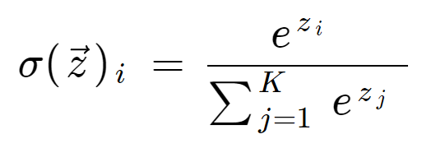

where all the zi values are the elements of the input vector and can take any real value.

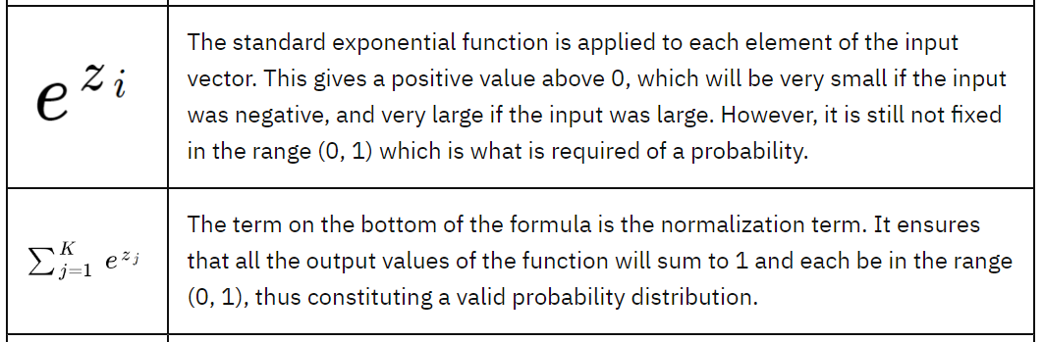

Example:

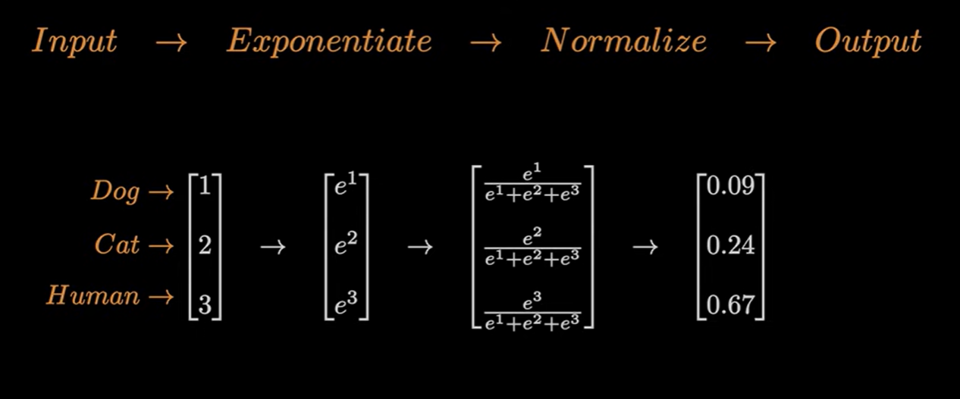

In above, the sum of Exponential + Normalize Steps is done using Softmax function.

**Which Activation Function for Outer Layer (or) Why Softmax over tanh or Linear Function**

Neural network models can be used to model classification predictive modeling problems. Classification problems are those that involve predicting a class label for a given input.

BUT, **what is the probability of it belonging to each of the known class labels? Or do we even need this individual probability for each class for outer layer?**

* **For a binary classification problem**, a Binomial probability distribution is used. This is achieved using a network with a single node in the output layer that predicts the probability of an example belonging to class 1. Here we could use any activation fn in outer layer like tanh or sigmoid or softmax etc.
* **For a multi-class classification problem**, the number of neurons in the output layer depends on the number of classes in the dataset. Say we have three classes in the dataset, then we will have three neurons in the output layer. Each of these neurons will give the probability of individual classes. This means the first neuron will give you the probability that the data point belongs ONLY TO CLASS 1. Similarly, the second neuron will give you the probability that the data point belongs ONLY TO CLASS 2 and so on………( if we had used tanh or sigmoid etc.)

This is a problem because these values may be difficult to work with. Here the softmax is very useful because it converts the scores to a normalized probability distribution, which can be displayed to a user or used as input to other systems. Thus, [Multinomial probability](https://machinelearningmastery.com/discrete-probability-distributions-for-machine-learning/) like Softmax Function is used. It works by using a network with one node for each class in the output layer such that the sum of the predicted probabilities from each class equals one.

**Softmax Function vs Sigmoid Function:**

The softmax function and the sigmoid function are similar. The softmax operates on a vector (see above for example) while the sigmoid takes a scalar.

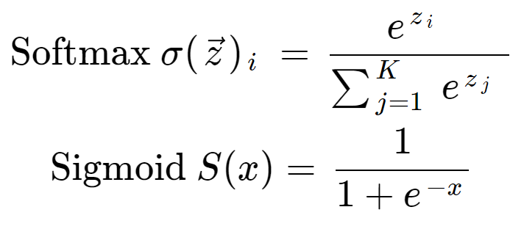

**In fact, the sigmoid function is a special case of the softmax function for a classifier with only two input classes.** We can show this if we set the input vector to be [x, 0] and calculate the first output element with the usual softmax formula **(PROOF NOT NEEDED, SKIPPED).**

FINAL NOTE: **If we are developing a two-class classifier with logistic regression, we can use the sigmoid function and do not need to work with vectors. But if we have more than two mutually exclusive classes the softmax should be used.**

**LOSS AND COST FUNCTIONS:**

Individual errors are called Loss ,and

Cumulated Errors are called Cost .

**For Regression Problems:** Choice for Loss and Cost function is “**Error**” and “**Mean Absolute Error**” (see below).

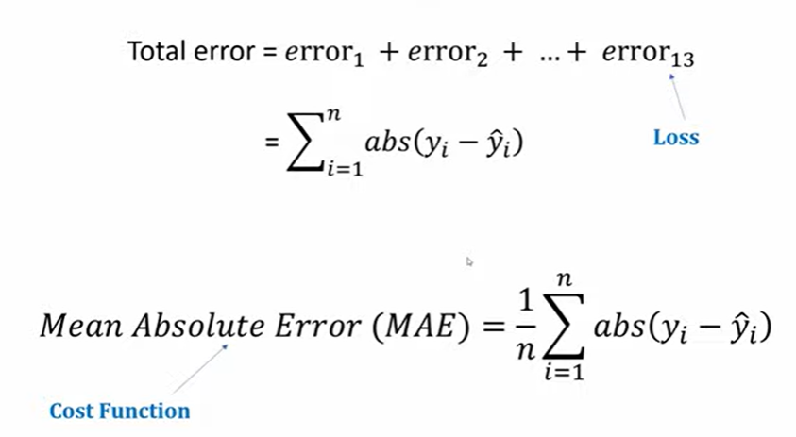

Implementing NN in Regression:

**NOTE: In Regression, we don’t need to put restriction on the final output values(like in classification the values must be 0 or 1 ). Thus, in Regression we don’t use any Activation function. Thus, the output layer in Regression is just the Linear Equation i.e. as output = input*weight +bias (a linear eqn indeed).**

* **Step 1.** Start with some random values of weights and biases for each Neuron.
* **Step 2.** Pass the input values in a batch one by one to the NN and this NN gives the final output value/predicted value called y_hat. Based on this, get Loss = y – y_hat.
* **Step 3**. Then using the “Gradient Descent” update these values of weights and biases.
* **Step 4**. Again pass the input values to this updated NN and calculate loss L which should have decreased in comparison to last value.
* **Step 5**. Repeat these steps 1-4 till we get an optimal/acceptable value of Loss L.

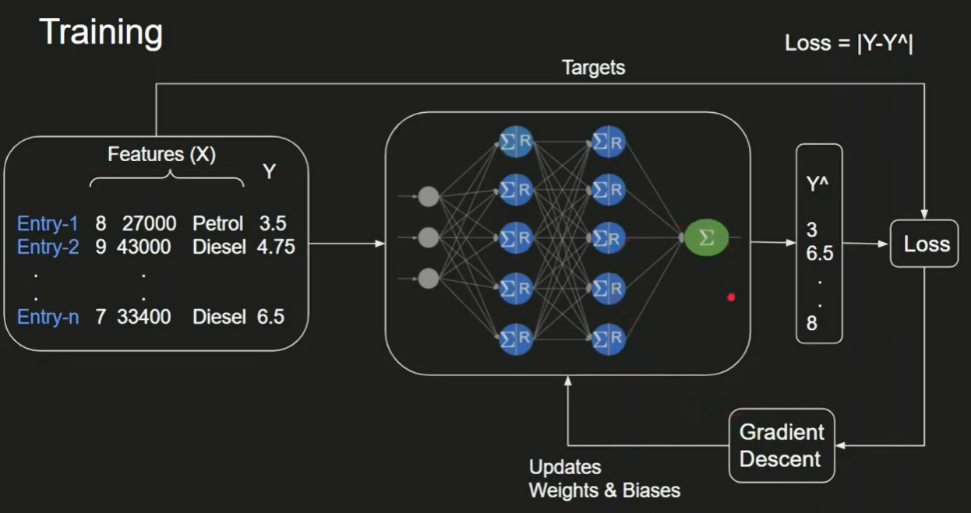

**For Classification Problems:** Choice for loss and Cost Function is “**Categorical Cross Entropy**”.

**NOTE:** The input to this function, “y_hat”, is taken from the Output layer of neurons which MUST use the “Softmax Activation Function”**.** Thus y_hat for each class are probability values which add upto 1.

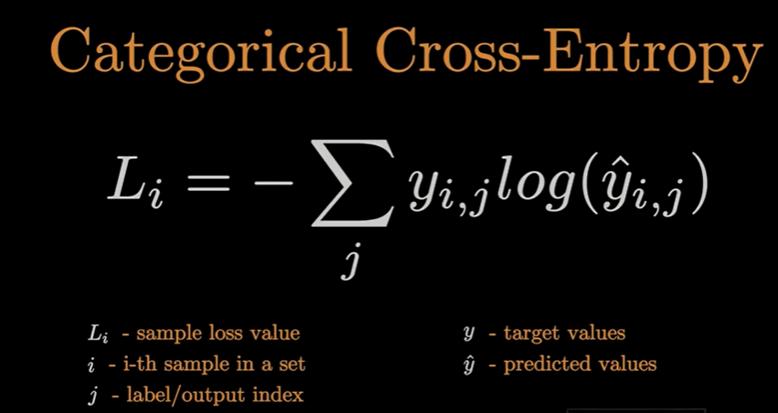

This simplifies to (below), because of One Hot Encoding .

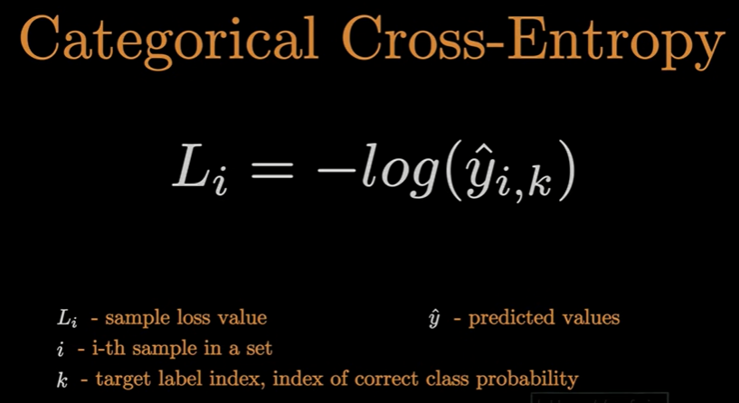

Explanation/Hint (see below fig.): Observe the 2nd and 3rd term goes to 0 b/c of OHE. …..Hence the formula gets simplified to “ Negative log of the target class i.e Li = -log(y_hat)”

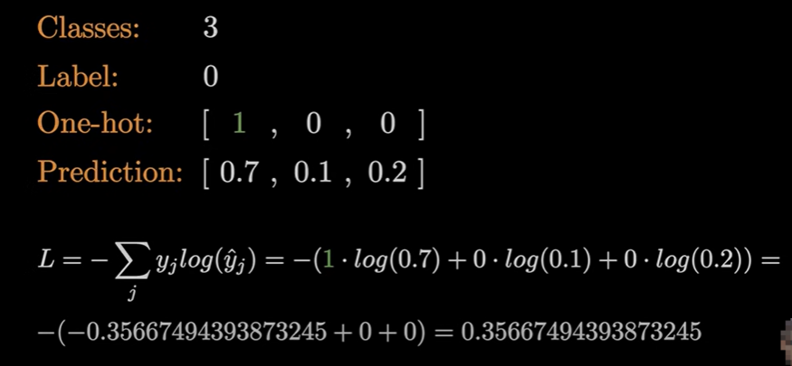

**INTERPRETATION OF CATEGORICAL CROSS ENTROPY VALUES:**

Higher the value of the Loss Function or L, the lower there is Confidence in the predicted value. i.e. predicted value is closer to Incorrect value.

Slly, lower the value of the Loss or L, the higher there is Confidence in the predicted value. i.e. predicted value is closer to Correct value.

**EXAMPLE:** Consider 3 class classification problem with 3 possible classes being dog,cat and human. First set of data contains 3 images which are of dog, cat and the third one is also cat . Hence our class target becomes [0,1,1]. The algo classifies the 1st image with a probability of 70% as a dog, 10% as a dog, and 20% as a human. Slly, it classified the 2nd and third image with values [0.1, 0.5, 0.4] and [0.02, 0.9, 0.08] as shown in “softmax_outputs” 2d array below.

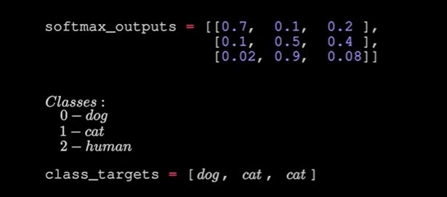

Now consider just the first image with y_hat = predicted values for 1st image as [0.7, 0.1, 0.2]. And wkt for calculating Loss or L , we only need to see the -log (y_hat for that class) i.e. here since the class is 0 i.e. dog . Hence, for first image the L value is -log(0.7) = 0.3566

Now consider just the second image with y_hat = predicted values for 2nd image as [0.1, 0.5, 0.4] And wkt for calculating Loss or L , we only need to see the -log (y_hat for that class) i.e. here since the class is 1 i.e. cat. Hence, for second image the L value is -log(0.5) = 0.693

Now consider just the third image with y_hat = predicted values for 3rd image as [0.02, 0.9, 0.08] And wkt for calculating Loss or L , we only need to see the -log (y_hat for that class) i.e. here since the class is also 1 i.e. cat class . Hence, for second image the L value is -log(0.9) = 0.1053

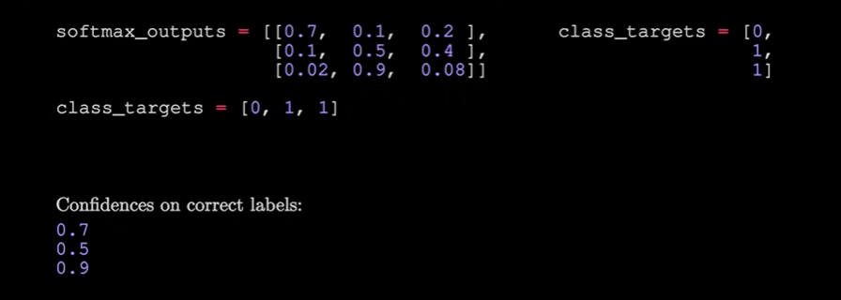

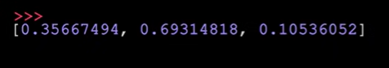

**Why not use Accuracy instead of Loss or Cost?**

Accuracy is also used in N.N. But it is only used to report the performance of our Model, not optimize/Improve it.

Accuracy is simply “**Total correct classifications divided by the total number of inputs/outputs**”.

However, when we want to optimize or Improve our Model, the metric that we are looking for is always “Loss or Cost Function”.

**To Improve our Model, our goal is to decrease this Loss L or Cost Function. To do this we adjust the values of “Weights and Biases”. But, how? This step is called Optimization using Gradient Descent.**

**GRADIENT DESCENT:**

It is the technique used to find/arrive at our Prediction Function(equation) i.e. find the coeff w and b for the Optimal Eqn. It is used during training of a N.N.

Example:

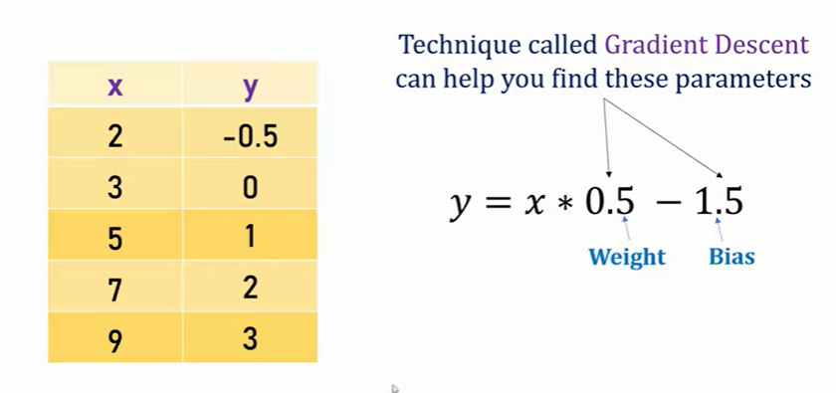

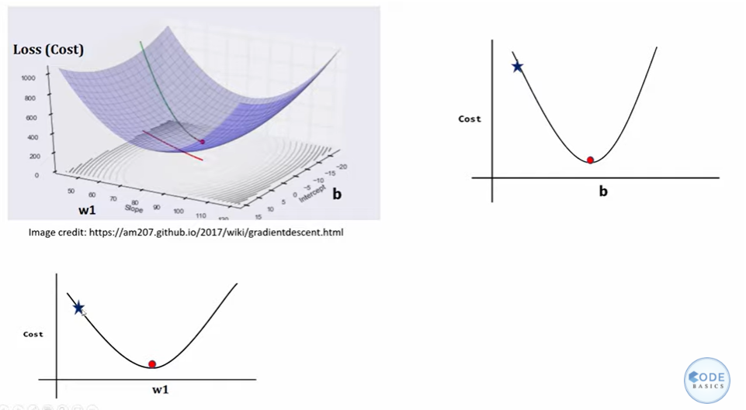 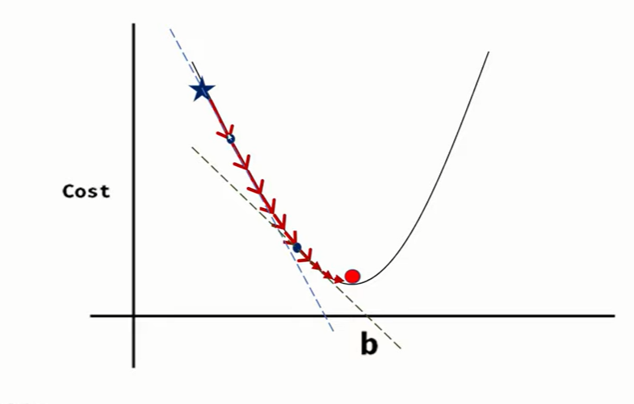

This is a technique that helps to learn **the parameters w and b in such a way that the cost function is minimized**. For example, the cost function for logistic regression is convex in nature (i.e. only one global minima) and that is the reason for choosing this function instead of the squared error (can have multiple local minima).

Let’s look at the steps for gradient descent:

1. Initialize w and b (usually initialized to 0 for logistic regression)
2. Take a step in the steepest downhill direction
3. Repeat step 2 until global optimum is achieved 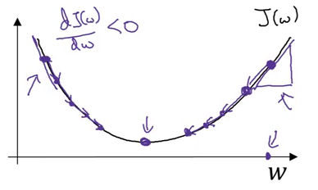

**FIG**: Cost function v/s Coeff w (or b)

where, ⍺ is the learning rate that controls how big a step we should take after each iteration, and, J(w,b) is the Cost function for the entire Training set.

**NOTE**: Loss function is defined for a single training example which tells us how well we are doing on that particular example. On the other hand, a cost function is for the entire training set.

(from figure above)……If we are on the right side of the graph shown above, the slope will be positive. Using the updated equation (see below), we will move to the left (i.e. downward direction, w decreases and Cost decreases) until the global minima for Cost is reached. Whereas if we are on the left side, the slope will be negative and hence we will take a step towards the right (downward direction, w increases and Cost decreases) until the global minima for Cost is reached. Pretty intuitive, right?

Thus, we update the parameters (w and b) of the equations for logistic regression after each Iteration as:

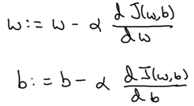

**Stochastic Gradient Descent vs Batch Gradient Descent vs Mini Batch Gradient Descent:**

**Batch Gradient Descent:**

* Here, we go through the entire Training data Set once (i.e. complete 1 epoch) and then calculate the Cumulative Error (= sum of all individual errors ) and then get Cost function, which can be calculated as Mean squared Error. So that’s just one gradient descent step in one epoch. And then next Gradient descent in next epoch ……so on

Example, we have below, 6 samples in a dataset. Thus, 1 epoch is passing all these 6 samples once . Then we calculate error each time or each step and then MSE (= cost fn)

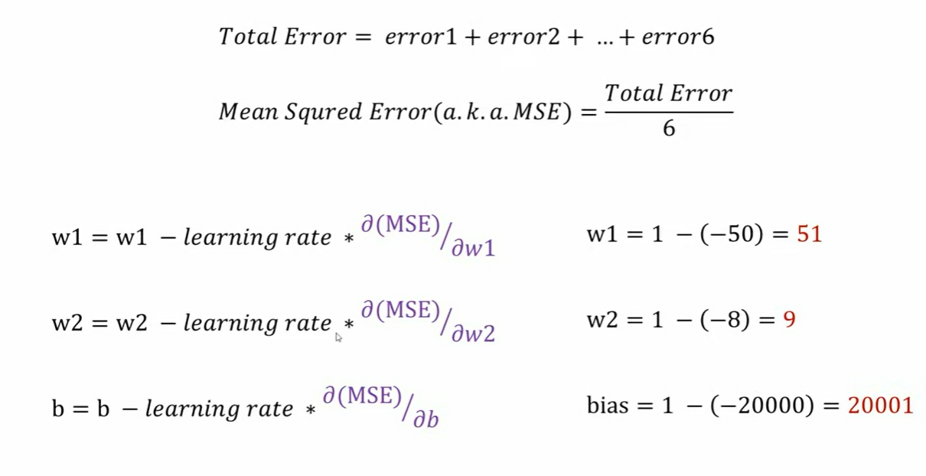

* Now, we backpropagate and adjust your w and b, as shown above and then again run the entire Training Data Set through your data(i.e. complete 2nd epoch) and repeat step 1.
* Keep on running these Epochs until the Error value reduces to the least possible value. Then stop.

**Stochastic Gradient Descent:**

BUT, what if in above example, if we have say, 10 million samples instead of 6 ??

This is a problem which should NOT be dealt with Batch Gradient method b/c

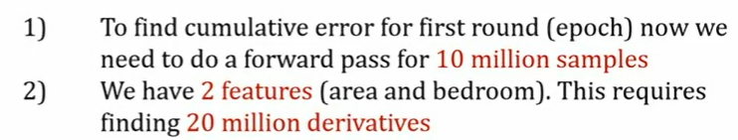

Hence if we used Batch GradIent, this is too much computation just to get 1 derievative/or, 1 Gradient Descent per 10 million samples (or, 1 epoch).

Thus, we go for Stochastic Gradient approach.

In Stochastic Gradient Descent (SGD), we consider just one sample at a time to get a single Gradient per sample. We do the following steps in **one epoch** for SGD:

1. Take one sample.
2. Feed it to Neural Network.
3. Calculate it’s gradient.
4. Use the gradient we calculated in step 3 to update the weights and biases.
5. Repeat steps 1–4 for all the samples in training dataset.

## **Difference between Batch Gradient Descent and Stochastic Gradient Descent**

| **S.NO.** | **Batch Gradient Descent** | **Stochastic Gradient Descent** |
| --- | --- | --- |
| 1. | Computes gradient using the whole Training sample | Computes gradient using a single Training sample |
| 2. | Slow and computationally expensive algorithm | Faster and less computationally expensive than Batch GD |
| 3. | Not suggested for huge training samples. | Can be used for large training samples. |
| 5. | Gives optimal solution given sufficient time to converge. | Gives good solution but not optimal. |
| 6. | No random shuffling of points are required. | The data sample should be in a random order, and this is why we want to shuffle the training set for every epoch. |
| 7. | Can’t escape shallow local minima easily. | SGD can escape shallow local minima more easily. |
| 8. | Convergence is slow. | Reaches the convergence much faster. |

**Mini Batch Gradient Descent:**

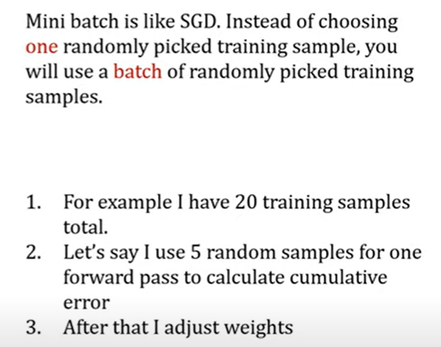

Derivatives of Various activation functions:

* Derivation of Sigmoid activation function:

g(z) = 1 / (1 + np.exp(-z))

g'(z) = (1 / (1 + np.exp(-z))) * (1 - (1 / (1 + np.exp(-z))))

g'(z) = g(z) * (1 - g(z))

* Derivation of Tanh activation function:

g(z) = (e^z - e^-z) / (e^z + e^-z)

g'(z) = 1 - np.tanh(z)^2 = 1 - g(z)^2

* Derivation of RELU activation function:

g(z) = np.maximum(0,z)

g'(z) = { 0 if z < 0

1. if z >= 0 }

* Derivation of leaky RELU activation function:

g(z) = np.maximum(0.01 * z, z)

g'(z) = { 0.01 if z < 0

1 if z >= 0 }

BACK PROPOGATION:

Let’s just start off with an extremely simple network, one where each layer has a single neuron in it.

So this particular network is determined by 3 weights and 3 biases,

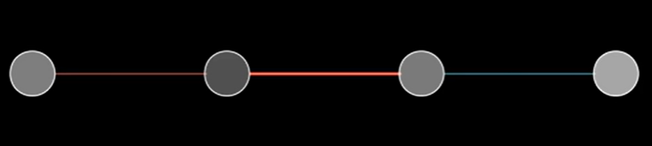

And our goal is to understand how sensitive the cost function (i.e.C) is to these variables. That way we know which adjustments to these terms is going to cause the most efficient decrease to the cost function.

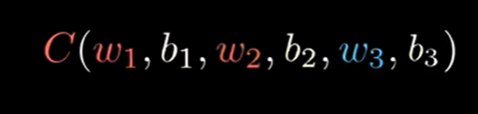

Here, C = cost function

w1, w2 , w3 = Weights

b1,b2,b3 = biases

Let's label the activation of that last neuron a with a superscript L, indicating which layer it’s in, so the activation of this previous neuron is a^(L-1).

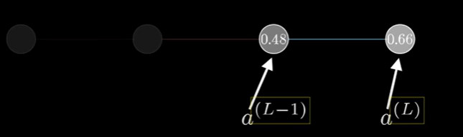 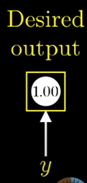

NOTE: These (a^(L-1) etc.) are not exponents, they're just a way of indexing what we’re talking about. Let’s say that the value we want this last activation to be for a given training example is y. For example, y might be 0 or 1.

So the cost of this simple network for a single training example is (a^(L) - y)^2 (b/c recall Cost function for Linear Regression is usually taken as (y_pred-y)^2 ). We’ll denote the cost of this one training example as C_0.

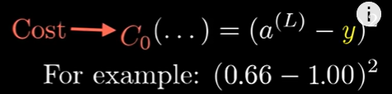

As a reminder, this last activation is determined by a weight, which I'm going to call w^(L) *( Note: w^(L) is just a notation to denote that this weight w is associated to the last neuron,or Lth neuron)* times the previous neuron’s activation, plus some bias, which I’ll call b^(L), then you pump that through some special nonlinear function like a sigmoid(here denoted by sigma) or a ReLU.

Thus, output of Acivation fn of Last Lth neuron is a^(L).

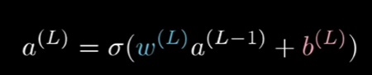

It's actually going to make things easier for us if we give a special name to this weighted sum, like z, with the same superscript as the relevant activations. So there are a lot of terms.

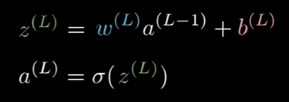

And a way you might conceptualize this is that the weight, the previous activation, and the bias altogether are used to compute z, which in turn lets us compute a, which finally, along with the constant y, lets us compute the cost.

All of these are just numbers, right?And it can be nice to think of each one as having its own little number line.

Our first goal is to understand how sensitive the cost function is to small changes in our weight w^(L). Or phrased differently, **what’s the derivative of C with respect to w^(L).**

When you see this “∂w” term, think of it as meaning “some tiny nudge to w”, like a change by 0.01. And think of this “∂C” term as meaning “whatever the resulting nudge to the cost is”.

What we want is their ratio .i.e. **the derivative of C with respect to w^(L).**

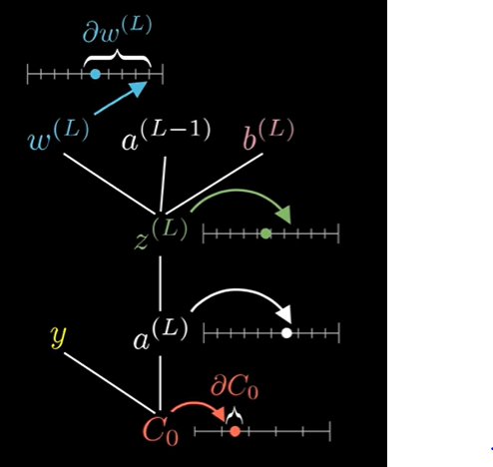 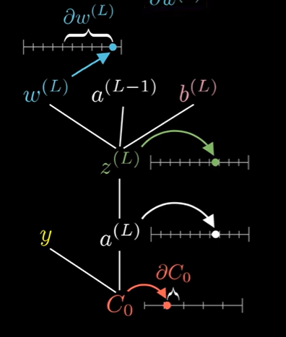

Conceptually, this tiny nudge to w^(L) causes some nudge to z^(L) which in turn causes some change to a^(L), which directly influences the cost.

So, we break this up by first looking at the ratio of a tiny change to z^(L) to the tiny change in w^(L). That is, the derivative of z^(L) with respect to w^(L). Likewise, you then consider the ratio of a change to a^(L) to the tiny change in z^(L) that caused it, as well as the ratio between the final nudge to C and this intermediate nudge to a^(L). (see Below Figure)

This right here is the chain rule, where multiplying together these three ratios gives us the sensitivity of C to small changes in w^(L).(see below)

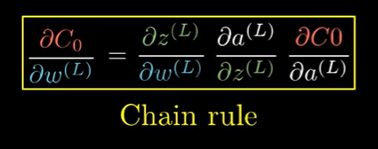

Now we are going to compute the relevant derivatives. (see below fig)

The derivative of C with respect to a^(L) works out to be 2(a^(L) - y).

( Notice, this means that its size is proportional to the difference between the network’s output, and the thing we want it to be. So if that output was very different, even slight changes stand to have a big impact on the cost function) .

The derivative of a^(L) with respect to z^(L) is just the derivative of our sigmoid function,

or whatever nonlinearity you choose to use.

And the derivative of z^(L) with respect to w^(L), in this case comes out just to be a^(L-1).

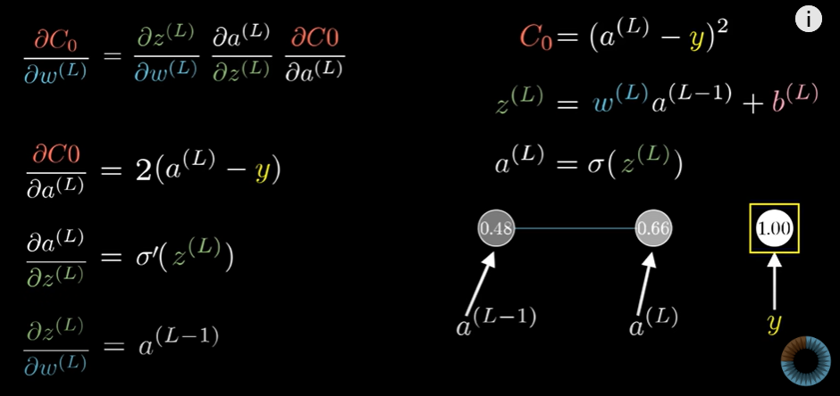

And all of this is the derivative with respect to w^(L) only of the cost for a specific training example. Since the full cost function involves averaging together all those costs across many training examples, its derivative requires averaging this expression that we found over all training examples.(i.e averaging over all the training samples i.e. in an epoch).

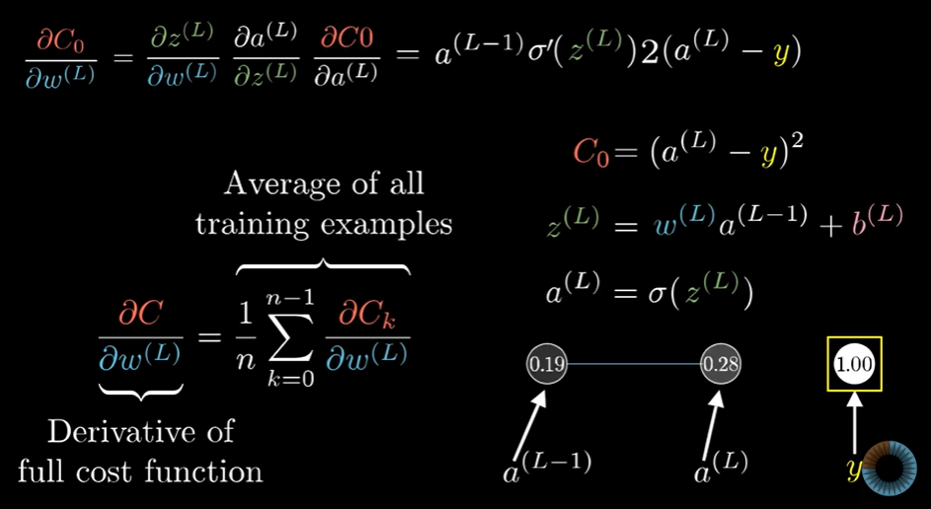

And of course that is just one component of the gradient vector, which itself is built up from the partial derivatives of the cost function with respect to all those weights and biases.

Thus, we will need to carry out this calculation for dC w.r.t. w1,w2,b1,b2 as well.

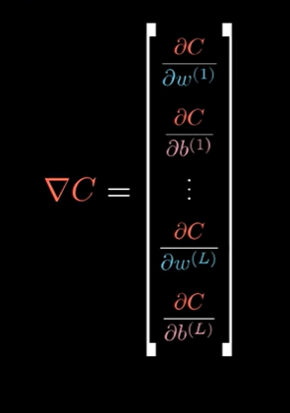

However the steps are very similar 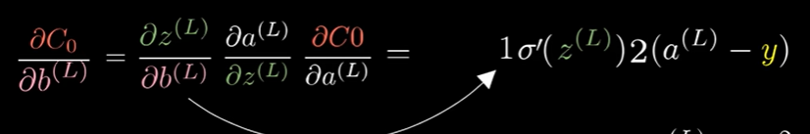

**Now we can just keep iterating this chain rule idea backwards to see how sensitive the cost function is to previous weights and to previous biases.**

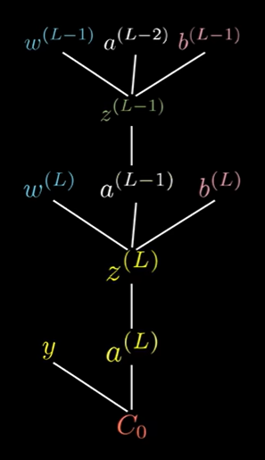 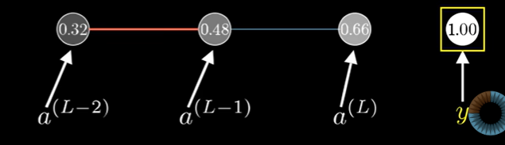

**LAYERS WITH MULTIPLE NEURONS** : Everything is essentially the same (as explained above), except a few Notations are changed and lengthier terms (with same meaning as previously explained) appear.

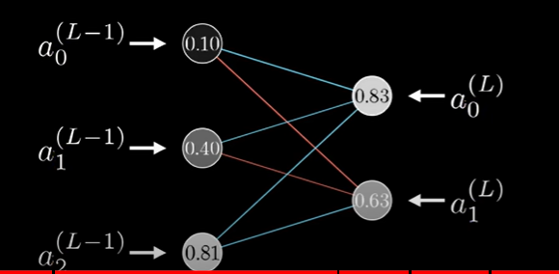

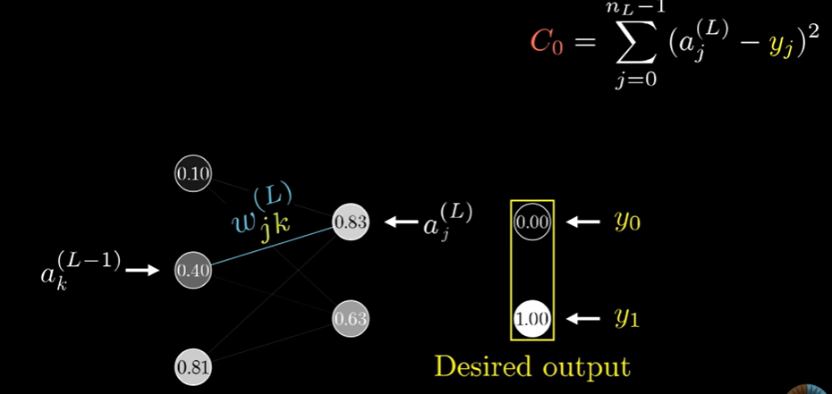

Now, Z becomes as :

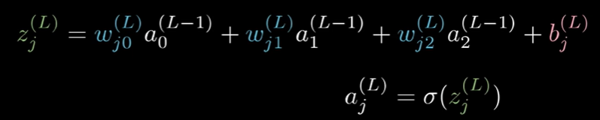

BUT, here **the Cost function** will be the “sum of Cost at all OUTPUT NEURONS”

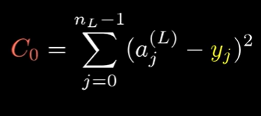

And, again here also : a= activation fn, like sigmoid .

Now, we again use Chain Rule to get our derivatives of C wrt w1, and eventually wrt w2,w3….. and then wrt b1,b2,b3……so on.

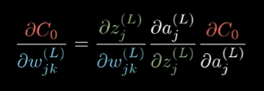

BUT, WE HAVE A TWIST HERE, WITH THE TERM

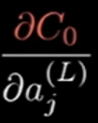 because the outer layer has 2 neurons. Thus,  will be the Sum of dCo/dao and dCo/da1 .

NOTE: These chain rule expressions give you the derivatives that determine each component in the gradient that helps minimize the cost of the network by repeatedly stepping downhill. (see below).

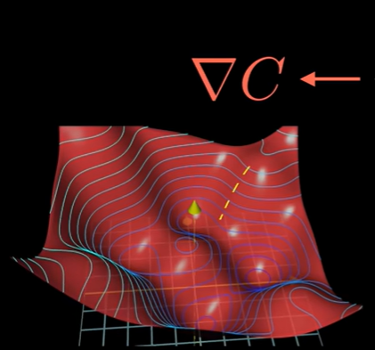

ADVANCE NEURAL NETWORK

1. Regularizing your Neural Network

In statistics, the bias of an estimator (or bias function) is the difference between this estimator's expected value and the true value of the parameter being estimated. An estimator or decision rule with zero bias is called unbiased.

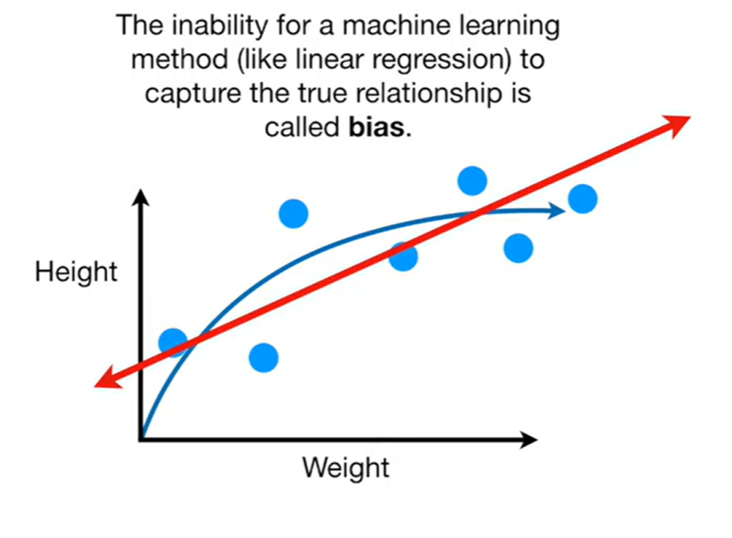 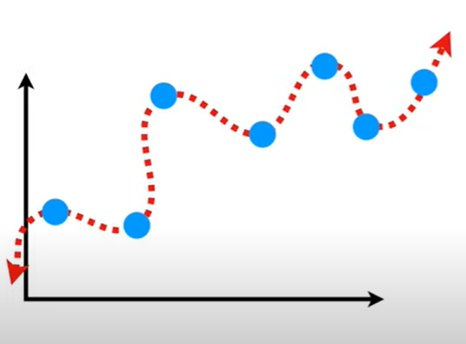 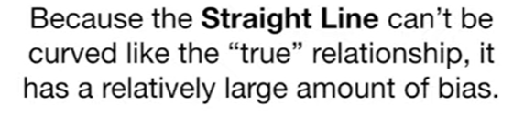

**AND SQIGGLY LINE HAS LESSER BIAS THAN STRAIGHT LINE.**

**However,** **when we test the Model performance using TESTING DATA**, the Straight line has lesser Variance than Squiggly line i.e . The Straight line model fits the Test data better because the sum of squares of the distance of the Test data pts. from the Mean (i.e. the fit line ) is lesser for Straight line .

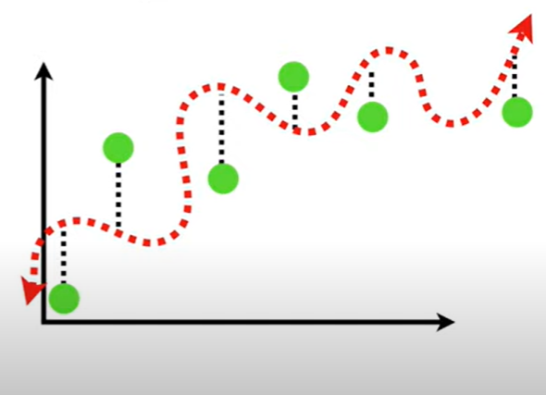 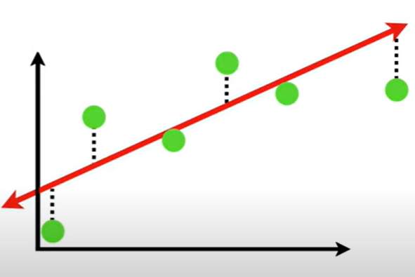

Thus, we say that the Straight line model has lesser Variance compared to Squiggly Line, however it has high Bias.This is an example of Underfitting.

VARIANCE FORMULA :

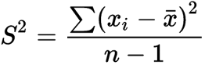

And slly, Squiggly Line has 0 Bias and very high Variance, is an example of Overfitting.

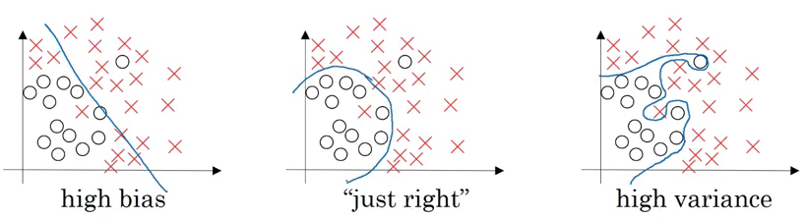

We want our model to be just right**, which means having low bias and low variance**. We can decide if the model should have high bias or high variance by checking the train set and dev set error. Generally, we can define it as:



* If the dev set error is much more than the train set error, the model is overfitting and has a high variance
* When both train and dev set errors are high, the model is underfitting and has a high bias
* If the train set error is high and the dev set error is even worse, the model has both high bias and high variance
* And when both the train and dev set errors are small, the model fits the data reasonably and has low bias and low variance

**And thus, while preparing Model, we find the sweet spot between Underfit model and OverFit Model by Reguralization**

**Regularizing your Neural Network:**

**One of the most popular techniques to reduce variance is called regularization.**

Note: If the dev/Test set error is high, we can say that the model has high variance. To reduce the variance, we can **get more data**, or, **use regularization,** or **try different neural network architectures**.

**how in the world does regularization prevent overfitting in the model?** Let’s try to understand it in the next section.

**How does regularization reduce overfitting?**

The primary reason overfitting happens is because the model learns even the tiniest details present in the data. So after learning all the possible patterns it can find, the model tends to perform extremely well on the training set but fails to produce good results on the dev and test sets. It falls apart when faced with previously unseen data.

**1. L2 Regularization**: One way to prevent overfitting is to reduce the complexity of the model. This is exactly what regularization does! If we set the regularization parameter (ƛ) to a large value, the decay in the weights(decrease in value of w after back propagation and adjusting) during gradient descent update will be more. Hence, the weights of most of the hidden units will be close to zero.

Since the weights are negligible, the model will not learn much from these units. This will end up making the network simpler and thus reduce overfitting:

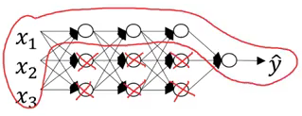

**2. Dropout Regularization (Preferred 99% of the time )**

There is one more technique we can use to perform regularization. Consider you are building a neural network as shown below:

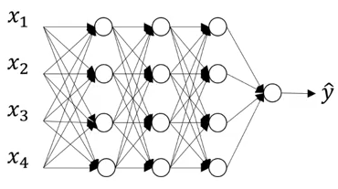

This neural network is overfitting on the training data. Suppose we add a dropout of 0.5 to all these images. The model will randomly remove 50% of the units from each layer and we finally end up with a much simpler network:

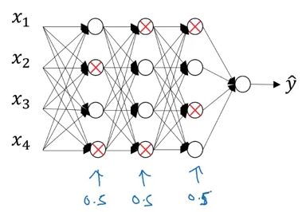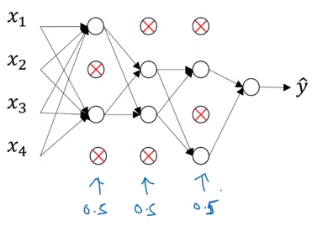

This has proven to be a very effective regularization technique.

Let’s understand the concept of dropout using an example:

Number of units in the layer = 50

keep_prob = 0.8

So, 20% of the total units (i.e. 10) will be randomly shut off

Note:

1. **That dropout is only done at the time of training the model (not during the test phase). The reason for doing this is because:**

* We don’t want our outputs to be random
* Dropout adds noise to the predictions

1. **Different sets of hidden layers are dropped randomly in each training iteration, automatically**.

RANDOM TOPICS::

# Callbacks API

A callback is an object that can perform actions at various stages of training (e.g. at the start or end of an epoch, before or after a single batch, etc).

You can use callbacks to:

* Write TensorBoard logs after every batch of training to monitor your metrics
* Periodically save your model to disk
* Do early stopping
* Get a view on internal states and statistics of a model during training
* ...and more

## Usage of callbacks via the built-in fit() loop

You can pass a list of callbacks (as the keyword argument callbacks) to the .fit() method of a model:

my_callbacks = [

tf.keras.callbacks.EarlyStopping(patience=2),

tf.keras.callbacks.ModelCheckpoint(filepath='model.{epoch:02d}-{val_loss:.2f}.h5'),

tf.keras.callbacks.TensorBoard(log_dir='./logs'),

]

model.fit(dataset, epochs=10, callbacks=my_callbacks)

The relevant methods of the callbacks will then be called at each stage of the training.

## Using custom callbacks

Creating new callbacks is a simple and powerful way to customize a training loop.